ETSI TR 103 526 V1.1.1\_0.0.17 (2017-12)

System Reference document (SRdoc);

Technical characteristics for Low Power Wide Area Networks

Chirp Spread Spectrum (LPWAN-CSS) operating in the UHF

spectrum below 1 GHz

<

**TECHNICAL REPORT**

Reference

DTR/ERM-TG28-565

Keywords

IoT; Energy Management; intelligent homes & buildings; smart city; smart meter; Smart Grid, SRdoc

***ETSI***

650 Route des Lucioles

F-06921 Sophia Antipolis Cedex - FRANCE

Tel.: +33 4 92 94 42 00 Fax: +33 4 93 65 47 16

Siret N° 348 623 562 00017 - NAF 742 C

Association à but non lucratif enregistrée à la

Sous-préfecture de Grasse (06) N° 7803/88

***Important notice***

The present document can be downloaded from:  
<http://www.etsi.org/standards-search>

The present document may be made available in electronic versions and/or in print. The content of any electronic and/or print versions of the present document shall not be modified without the prior written authorization of ETSI. In case of any existing or perceived difference in contents between such versions and/or in print, the only prevailing document is the print of the Portable Document Format (PDF) version kept on a specific network drive within ETSI Secretariat.

Users of the present document should be aware that the document may be subject to revision or change of status. Information on the current status of this and other ETSI documents is available at <https://portal.etsi.org/TB/ETSIDeliverableStatus.aspx>.

If you find errors in the present document, please send your comment to one of the following services:  
<https://portal.etsi.org/People/CommiteeSupportStaff.aspx>

***Copyright Notification***

No part may be reproduced or utilized in any form or by any means, electronic or mechanical, including photocopying and microfilm except as authorized by written permission of ETSI.

The content of the PDF version shall not be modified without the written authorization of ETSI.

The copyright and the foregoing restriction extend to reproduction in all media.

© ETSI yyyy.

All rights reserved.

**DECT**TM, **PLUGTESTS**TM, **UMTS**TM and the ETSI logo are trademarks of ETSI registered for the benefit of its Members.  
**3GPP**TM and **LTE**™ are trademarks of ETSI registered for the benefit of its Members and  
of the 3GPP Organizational Partners.  
**oneM2M** logo is protected for the benefit of its Members.  
**GSM**® and the GSM logo are trademarks registered and owned by the GSM Association.

Contents

Intellectual Property Rights 5

Foreword 5

Modal verbs terminology 5

Executive summary 5

Introduction 5

1 Scope 6

2 References 6

2.1 Normative references 6

2.2 Informative references 6

3 Definitions, symbols and abbreviations 7

3.1 Definitions 7

3.2 Symbols 7

3.3 Abbreviations 7

4 Comments on the System Reference Document 8

4.1 Statements by ETSI Members 8

5 Presentation of the system or technology 12

5.1 Overview 12

5.2 The LoRaWAN™ protocol 14

5.2.1 Overview of the protocol 14

5.2.2 End Node 14

5.2.2 Gateway 14

5.2.3 Network Server 15

5.2.4 Adaptive Data Rate 15

5.2.5 Application Server 16

6 Market information 16

7 Technical information 19

7.1 Detailed technical description 19

7.1.1 LPWA-CSS signals 19

7.2 Technical parameters and implications on spectrum 20

7.2.1 General technical parameters 20

7.2.2 Status of technical parameters 25

7.2.2.1 Current ITU and European Common Allocations 25

7.2.2.2 Sharing and compatibility studies (if any) already available 25

7.2.2.3 Sharing and compatibility issues still to be considered 25

7.2.2 Transmitter parameters 25

7.2.2.1 Transmitter Output Power / Radiated Power 25

7.2.2.1.1 Antenna Characteristics 25

7.2.2.2 Operating Frequency 25

7.2.2.3 Out of band emissions 26

7.2.2.4 Spurious emissions 26

7.2.3 Receiver parameters 28

7.2.3.1 Sensitivity 28

7.2.3.2 Adjacent channel rejection 29

7.2.3.3 Blocking 29

7.2.3.4 Intermodulation response rejection 32

7.2.4 Channel access parameters 33

7.3 Information on relevant standard(s) 34

8 Radio spectrum request and justification 35

9 Regulations 35

9.1 Current regulations 35

9.2 Proposed regulation and justification 36

Annex A: Bibliography 38

Annex B: Main use cases in different verticals 39

Annex C: Interference Experimental setup 45

Receiver’s AWGN sensitivity 46

Continuous wave interference 47

GFSK modulated interferer 47

LPWAN-CSS modulated Interferer 49

Annex D: An example of interference measurement with a single LPWAN CSS link and a single periodic pulsed CW interferer 51

Annex E: Out of band emission measurements 52

Annex : Change History 55

History 56

# Intellectual Property Rights

Essential patents

IPRs essential or potentially essential to the present document may have been declared to ETSI. The information pertaining to these essential IPRs, if any, is publicly available for **ETSI members and non-members**, and can be found in ETSI SR 000 314: *"Intellectual Property Rights (IPRs); Essential, or potentially Essential, IPRs notified to ETSI in respect of ETSI standards"*, which is available from the ETSI Secretariat. Latest updates are available on the ETSI Web server (<https://ipr.etsi.org>).

Pursuant to the ETSI IPR Policy, no investigation, including IPR searches, has been carried out by ETSI. No guarantee can be given as to the existence of other IPRs not referenced in ETSI SR 000 314 (or the updates on the ETSI Web server) which are, or may be, or may become, essential to the present document.

Trademarks

The present document may include trademarks and/or tradenames which are asserted and/or registered by their owners. ETSI claims no ownership of these except for any which are indicated as being the property of ETSI, and conveys no right to use or reproduce any trademark and/or tradename. Mention of those trademarks in the present document does not constitute an endorsement by ETSI of products, services or organizations associated with those trademarks.

# Foreword

This Technical Report (TR) has been produced by ETSI Technical Committee Electromagnetic compatibility and Radio spectrum Matters (ERM).

# Modal verbs terminology

In the present document "**should**", "**should not**", "**may**", "**need not**", "**will**", "**will not**", "**can**" and "**cannot**" are to be interpreted as described in clause 3.2 of the [ETSI Drafting Rules](https://portal.etsi.org/Services/editHelp!/Howtostart/ETSIDraftingRules.aspx) (Verbal forms for the expression of provisions).

"**must**" and "**must not**" are **NOT** allowed in ETSI deliverables except when used in direct citation.

# Executive summary

The present document has been developed on request of CEPT to enable them to conduct compatibility studies on LPWAN-CSS (LoRaWAN™) systems.

The document contains information on the technical characteristics and parameters, as well as market relevant information on the LPWAN-CSS systems.

The document includes finally spectrum considerations to enable the market success of the LPWAN-CSS (LoRaWAN™) systems.

# Introduction

This SRdoc has been developed on request of CEPT WGFM to get a better description of LPWAN systems in the UHF frequency band.

# 1 Scope

The present document describes the LPWAN-CSS (Low Power Wide Area Networks - Chirp Spread Spectrum) system, also commercially known as LoRaWAN™, which aims to respond a CEPT ECC Working Group Frequency Management request to better understand the LPWAN-CSS characteristics in view of allowing spectrum considerations for conventional SRDs and SRD networks healthy sharing. It includes in particular:

* Market information;
* Technical information (including expected sharing and compatibility issues).
* Regulatory considerations

# 2 References

## 2.1 Normative references

Normative references are not applicable in the present document.

## 2.2 Informative references

References are either specific (identified by date of publication and/or edition number or version number) or non‑specific. For specific references, only the cited version applies. For non-specific references, the latest version of the referenced document (including any amendments) applies.

NOTE: While any hyperlinks included in this clause were valid at the time of publication ETSI cannot guarantee their long term validity.

The following referenced documents are not necessary for the application of the present document but they assist the user with regard to a particular subject area.

[i.1] “LoRaWAN™ 1.0.2 Specification”

NOTE: available by simply sending an email request to <mailto:admin@mail.lora-alliance.org>

[i.2] Hata, M. (August 1980). "Empirical Formula for Propagation Loss in Land Mobile Radio Services". IEEE Transactions on Vehicular Technology. VT-29 (3): 317–25.

[i.3] B.Reynders and S. Pollin, ”Chirp spread spectrum as a modulation technique for long range communication”, Symposium on Communications and Vehicular Technologies (SCVT), Mons, Belgium, November 2016, pp. 1-5.

[i.4] ETSI EN 300 220-1 V3.1.1 (11-2016) “Short Range Devices (SRD) operating in the frequency range 25 MHz to 1 000 MHz; Part 1: Technical characteristics and methods of measurement".

[i.5] ERC Recommendation 70-03 “Relating to the Use of Short Range Devices (SRD)” Tromsø 1997 Subsequent amendments 19 May 2017[

i.6] COMMISSION IMPLEMENTING DECISION (EU) 2017/1483,  Official Journal of the European Union 18-8-2017

[i.7] ECC Report 261. Short range devices in the frequency range 862-870 MHz range. January 2017.

[i.8] ECC Report 246. Wideband and Higher DC Short Range Devices in 870-875.8 MHz and 915-920.8 MHz (companion to ECC Report 200). January 2017

# 3 Definitions, symbols and abbreviations

## 3.1 Definitions

For the purposes of the present document, the terms and definitions given in [1],[2] and the following apply:

**Application server:** The application Server (AS) terminates the application layer for the end devices connected to a Network Server; there can be multiple instances of the Application Server, each one serving a different application or a different group of applications

**End-device or End-node**: a LoRaWAN™ client device communicating via a radio link with gateways; the correspondent ETSI/CEPT term is “Terminal Node (TN)”

**Gateway**:a radio system on the infrastructure-side. Communicates with end-devices and, via IP, with a network server; the correspondent ETSI/CEPT term is “Network Access Point (NAP)”

**Network server**: The Network Server (NS) termination entity for the LoRaWAN™ protocol for the end-devices connected to the network. It is the centre of the star topology as shown in **Figure 1**.

**Occupied bandwidth:** width of a LPWAN CSS signal band such that, below the lower and above the upper frequency limits, the mean power emitted are each equal to 0,5 % of the total mean power of a given emission.

**Time overhead**: time taken to transmit everything else which is not payload

## 3.2 Symbols

For the purposes of the present document, the symbols given in [1], [2] and the following] apply:

bps bits per second

dB decibel

dBi decibels of antenna gain referenced to a hypothetical isotropic antenna

dBd decibels of antenna gain referenced to a half-wave dipole antenna

dBm decibels of the power referenced to one milliwatt

dBc decibels of the power referenced to the power of the carrier

## 3.3 Abbreviations

For the purposes of the present document, the following abbreviations apply:

**AFA**: Adaptive Frequency Agility;

**ADR** Adaptive Data Rate

**APC:**  Adaptive Power Control

**AS** Application Server

**AWGN:** Additive White Gaussian Noise

**CCA**: Clear Channel Assessment;

**CEPT:** Conférence européenne des administrations des postes et des télécommunications

**CRC:** Cyclic Redundancy Check

**CSS**: Chirp Spread Spectrum

**DR**: Data Rate

**E.R.P.**: Effective Radiated Power

**FSK**: Frequency Shift Keying

**GPS:** Global Positioning system

**GW:** Gateway

**HAL**: Hardware Abstraction Layer

**IoT**: Internet of Things

**IP:** Internet Protocol

**LBT**: Listen Before Talk

**LoRaWAN™**: the radio system specification as described in [i.1];

**LTE:** Long Term Evolution

**MAC:** Medium Access Control

**LoRa** Long Range and low energy radio RF technology developed by Semtech. LoRa® is a registered trademark of the Semtech Corporation.

**OFDM**: Orthogonal frequency Division Multiplexing

**OOB**: Out Of Band

**NF:** Noise Figure

**NS:** Network Server

**SNR:** Signal to Noise Ratio

**LPWAN:** Low Power Wide Area Networks

**LPWAN-CSS** LPWAN Chirp Spread Spectrum

**RF**: Radio Frequency

**SF:**  Spreading Factor

**WGFM**: Working Group Frequency Management

# 4 Comments on the System Reference Document

### 4.1 Statements by ETSI Members

**Source: Silver Spring Networks (UK) Ltd.**

(For further information contact Dr. Simon Dunkley *[sdunkley@ssni.com](mailto:sdunkley@ssni.com)*)

SSN (UK), a Full ETSI Member, actively participated in the preparation of this SRDoc and thanks Semtech for the depth and scope of the information contributed on the operation of the LoRa systems described. While not raising opposition to the completion of the SRDoc, a number of points where SSN (UK) opinions disagree with the authors are noted here in this clause to be considered along with the rest of the SRDoc material.

1. Relationship to studies carried out in ECC Report 261  
     
   SSN (UK) actively participated in CEPT WI 42-2 compatibility studies on SRDs in the 862-870MHz frequency range. ECC Report 261 included results of studies of interference into LPWAN basestations but using assumed parameters for the LPWAN receiver.  
     
   CEPT WGSE, at their 75th meeting in Berlin, January 2017, discussed Report 261 (among others) and minuted the decision to approve the report for publication. However, it was also noted that the studies on LPWAN used unrealistic system parameters. Section 9.1.1 of SE(17)035 Minutes of the 75th WGSE meeting, reporting the discussion on Report 261 states:  
     
   *“United Kingdom (SE(17)032) suggested further that the analysis of interference into LP-WAN technology should be revisited once the details of the LP-WAN technology have been established and a realistic set of victim system parameters agreed. United Kingdom is of the opinion that WG SE should commit to a new WI once the SRDoc on LP-WAN is received from ETSI.”*Requests by SSN (UK) to comment in this SRDoc on the relationship between the presented system parameters and those reported in ECC Report 261 assumed for LPWAN basestations were consistently refused on the basis that such comments were out of scope of the SRDoc. SSN (UK) considers that, since WGFM specifically requested this SRDoc because of a lack of technical detail for LPWAN systems to be used in compatibility studies, such comments would be fully in scope of this SRDoc and be of considerable interest to CEPT.
2. Interference from LoRa Systems   
     
   SSN (UK) notes that LPWAN systems are described as operating at both low and high power with Gateways often mounted at high elevations. SSN (UK) considers that, in addition to the usual compatibility investigations, studies of high power operation at high elevation, especially taking into account long continuous transmissions owing to low data rates, are required to determine the interference from LPWAN systems into other legitimate SRD devices in the bands.
3. LoRa System Waveform  
     
   SSN (UK) repeatedly requested more details of the LoRa system waveform and its modulation but these requests were denied on the basis that sufficient information is presented for the needs of CEPT compatibility studies. SSN (UK) believes this is not the case and that when CEPT studies are launched the need for additional information will become apparent. Not providing information in the SRDoc will simply lead to delays in the overall process.  
     
   SSN (UK) requests details of the modulation scheme used by LoRa systems so that when considering interference into LoRa devices the effects of the interferer signal on the LoRa receiver and demodulation mechanisms may be understood. Similarly, knowledge of the modulation process will assist in understanding the effects of LoRa waveforms as interferers into different victim devices.  
     
   In addition, it is currently impossible to verify some of the information presented since details of the modulation scheme are not available. For example, deriving the processing gain or even the bit rate from the Spreading Factor information is not possible.
4. Susceptibility to Interference  
     
   SSN(UK) notes that in Table 9, the claimed performance of the LoRa radios is exceptionally high, with the Noise Figure for the Gateway and End Device being 3dB and 7dB, respectively. Given that SRDs’ NF more typically lie in the range 7-20dB, these figures seem very high, especially for mass-produced end devices being produced for a few dollars. No measured values are given to corroborate these numbers, but it is noted that the ***claimed*** sensitivity is 32dB better than that required by EN 300 220.  
     
   Narrowband receivers achieving similar levels of sensitivity (cf. LPWAN UNB or Social Alarm receivers) protect their high sensitivity operation with strong adjacent band and blocking rejection. For example, a Cat 1 Social Alarm receiver available from a major component supplier offers sensitivity performance of -129dBm at 300bps in 12.5kHz together with adjacent channel selectivity of 67dB and blocking performance of 104dB at 10MHz from the wanted signal.  
     
   The LPWAN UNB SRDoc (TR 103 435) gives sensitivity of -136dBm in 250Hz with adjacent channel selectivity of approximately 60dB and blocking of better than 90dB at 10MHz offsets.  
     
   These figures compare to the LoRa parameters presented in the SRDoc, for a -122dBm wanted signal, of sensitivity of -128dBm to -142dBm in 125kHz at 250bps data rate with adjacent channel selectivity of only 15dB and approximately 80dB blocking performance extrapolating the provided data to 10MHz.  
     
   The performance of such receivers could only be exploited in areas where interference from other spectrum users is absent, such as rural areas. Clearly, the system is designed to extract signals out of uncorrelated noise, but in real environments – especially urban environments – the noise floor will likely rise by 10-20dB from other ‘interfering’ SRDs. With the receiver parameters provided in the SRDoc, none of the modes would be robust. According to the description given, changing SF modes simply trades off data rate, and so no mode allows the LoRa devices to be more robust to other devices with which they must share the band.
5. Time Domain Behaviour  
     
   SSN (UK) notes that the LPWAN-CSS system description in this SRDoc includes highly interesting and relevant details of robust receiver performance exploiting a priori knowledge of the expected waveform. Implementations achieve substantial processing gain where interference is discontinuous and adequate LPWAN-CSS symbols are received to recover the transmitted information. Such characteristics are important indications of the processing gain and error coding protection inherent in the LoRa waveform.  
     
   SSN (UK) considers it highly relevant to include LPWAN-CSS receiver performance in real sharing scenarios when such features are present in the new system since CW interferers do not represent active transmissions of real SRDs sharing the spectrum. Discontinuous transmissions are realistic models for packet communications which form the vast majority of SRD systems in the concerned bands.  
     
   Annex D**[[1]](#footnote-1)** highlights the ‘sweet spot’ of the system. Depending on the mode in which any one link is operating, the performance of the radio is improved dramatically from these unfeasibly sensitive values, by a factor of 80dB, if interfering signals’ durations are restricted to certain ranges (depending on the SF).  
     
   The ranges are:

|  |  |  |
| --- | --- | --- |
| SF | Min duration (ms) | Max duration (ms) |
| 12 | 0.1 | 100 |
| 7 | 0.1 or 0.003 (not clear if this scales, too) | 3 |

The system is evidently setting up a homogeneous sharing environment in which operation of other devices in the band needs to conform to these narrow transmission timing constraints. Whilst we agree that in order for interference to SRDs to be minimised, long message times should be avoided – no longer than 400ms, as set out in EN 300 220 – constraining transmissions to less than 3ms (for SF7) before ‘claiming’ that significant interference is caused is unreasonable.

This SRDoc, therefore, describes a system that can efficiently extract signals out of uncorrelated noise, but is extremely vulnerable to the transmissions that are to be associated with typical SRD devices i.e. 100-400ms transmissions. It would appear, also, that this LPWAN-CSS system would be incompatible with the long transmissions of LPWAN UNB systems.  
  
Given the system’s sensitivity to the length of interfering signals, the SRDoc is remarkably scant on details of the length of its own transmissions.  
  
Studies may need to include Time Domain behaviour in order to accurately represent the behaviour of these new innovative systems. SSN (UK) notes that recent work in ETSI TG28 and relevant STFs has developed significantly improved mechanisms to specify short term and long term behaviour expressed as Duty Cycles which provide powerful tools for describing sharing scenarios deemed workable by CEPT compatibility studies.  
  
The time dependent behaviour of the LPWAN-CSS receiver is also expected to make LPWAN-CSS victims substantially more robust to adjacent channel and blocking interferers than the figures provided for continuous wave interference. **Indeed, it is interesting to note that in Report 261 where it was claimed that interference from NBN systems would be extremely harmful to LoRa basestations in the band 865-868MHz, the typical NBN transmissions of 1-100ms would have caused no harmful interference because an overly pessimistic (by ~80dB) interference criterion was used**.  
  
SSN (UK) repeatedly requested the receiver performance to be described for both CW and pulsed interferer cases as this would provide CEPT with a solid base from which to develop models for LPWAN-CSS systems as victims in future studies.   
  
Disappointingly, this important information was relegated to a one page Annex D in the final stages of drafting and only one reference to that Annex is made in clause 7.2.3.2. (It is noted that there are multiple references to Annex D but all but one are erroneous references to the Annex E spectra plots.)

1. Power Spectral Density Effects  
     
   SSN (UK) has studied the information present in the companion SRDoc on LPWAN-UNB systems. Initial indications are that under certain conditions the UNB waveform can interfere more severely than an equivalent wide(r) transmission owing to higher power spectral density. A spectrogram included in a LoRa Alliance ‘Technology 101’ presentation clearly shows a narrow LoRa signal repeatedly swept across the occupied channel as a function of time  
     
   SNN has requested information about the power spectral density of the LPWAN-CSS signal in order to evaluate potential new interference conditions not experienced with other waveforms. Since the UNB and CSS waveforms are both innovative advances in SRD transmission technologies, SSN (UK) believes this information may be necessary to consider new ways to evaluate their compatibility with other waveforms in sharing studies.  
     
   Unfortunately, LoRa waveform PSD information is not provided in this SRDoc.

**By ETSI Member Great Circle Design**

Contact: Nicholas Long

This is a preliminary set of comments for section 4.1. It is hoped that it can be revised as necessary if more information about the LoRa system is included in the SRdoc.

The subject areas for the comment are:

1. Lack of information about the signal
2. Traffic Model
3. Capacity constraints
4. Long range performance in practice

**Lack of information**

Despite repeated requests, the authors of the SRdoc have not included sufficient information about the signal transmitted. The missing information includes basic things such as:

* Number of bits per symbol
* Means of modulating the data onto the signal
* Spreading ratio (the Spreading Factor quoted is not the spreading ratio as normally understood in spread spectrum systems)

The lack of this information has not helped in preparing this comment and it is hoped it can be rectified.

**Traffic Model**

The SRdoc would benefit from an analysis of the predicted traffic expected on a LoRa channel.

There is a clue buried in Table 6, where it is shown that the duty cycle of an end node can be 0.016% or 0.0045%. These are remarkably precise figures and an explanation and analysis would be beneficial.

**Capacity Constraints**

Also missing is a discussion of the traffic capacity of a LoRa channel.

It appears that each signal in a 200 kHz channel has to be on a different SF (Spreading Factor). Since each SF corresponds to a different data rate and is optimised for a different range, it is expected that only one signal on the channel can be optimised and the others will have to run at lower than possible data rates.

It appears the maximum channel capacity can be found by adding up the data rates in Table 2 for SF=7 to SF=12.

5470 + 3125 + 1760 + 980 + 440 + 250 = 12,025 bits/sec

This is a remarkably low capacity for a 200 kHz channel. Indeed it would seem to make more sense to turn off the chirp spread spectrum option and just use the FSK mode that allows 50 kbps.

**Long range performance in practice**

One of the seeming advantages of LoRa is the ability to function as both a long range and a short range system; the SF can be chosen to suit the distance required.

What is not clear is how well this will work in practice. Information that was in an earlier draft but appears to be missing from the current one was a table of isolation, or separation, between the various SFs. This showed quite low levels of isolation; indeed the theory of chirp spread spectrum shows that they are not necessarily orthogonal data streams.

LoRa therefore suffers from a severe case of the near-far problem, in that separate data streams cannot be received unless they are close in amplitude.

Once the traffic gets above a certain level, long range communication becomes impossible as it is blotted out by the short range traffic. With the current lack of information in the SRdoc it is not possible to say at what level of usage this happens or whether this happens suddenly or gradually.

In this respect, however, the comment on p20 about “network densification” is revealing: …*a network operator seeing an increasing number of connections will increase the gateways density….*

This would conform the view that once a certain level of use is reached, then long range operation has to be abandoned. Table 6 gives a figure for gateway density of 3.5 per sq km, which would correspond with a maximum range of around 700 m.

# 5 Presentation of the system or technology

## 5.1 Overview

The LPWAN CSS system is mainly intended for applications which fall under the broad field of Internet of Things. There are many vertical applications which are part of this field and they are highlighted in Annex B.

The LPWAN CSS system comprises four entities: the end-device (also called end-node), the Gateway, the Network Server and the Application Server. The architecture describing the relationship between these entities is depicted in Figure 1. The Gateway, the Network Server and the Application Server are part of the infrastructure of the network.

The LoRaWAN™ protocol architecture is shown in Figure 2.

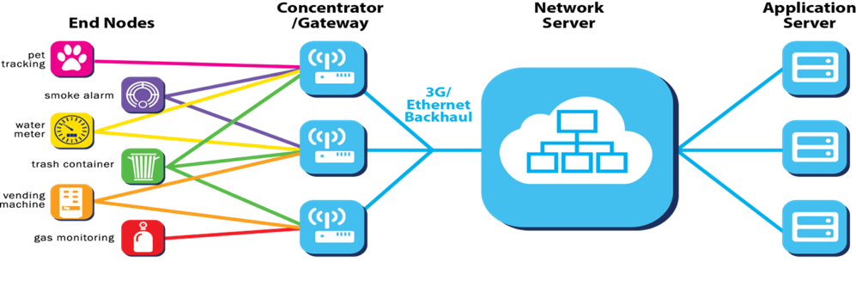

**Figure 1: the LoRaWAN™ architecture**



**Figure 2: LoRaWAN™ Protocol Architecture**

As far as the radio link is concerned, the LPWAN-CSS system is comprised of end nodes and gateways. LPWAN-CSS is a system comprised of end nodes and gateways. The end nodes are sensors and/or actuators equipped with a LPWAN-CSS radio transceiver. They are resources constrained in terms of processing power, memory and energy; in some cases, depending on the availability and the application, the end nodes can be attached to the main power and so the constraint on the energy is relaxed. Gateways are radio equipment able to receive and transmit LPWAN-CSS signals; gateway have powerful signal processing (analogue and digital) capabilities as well as medium-high computational capability (their processing unit may range from an ARM 9 to powerful dual or quad core ARM processors).

LPWAN-CSS end nodes communicate bi-directionally with one or more gateways, each gateway being connected with a central entity, the NS, controlling the network and connecting to external networks.

LPWAN-CSS is a system that includes the LoRaWAN™ (see section 5.2) protocols and radio access techniques, and uses the chirp spread spectrum. LoRaWAN™ is established and maintained by the Lo-Ra Alliance™ ([Lo-Ra Alliance website](https://www.lora-alliance.org/)).

~~The physical layer is working according to what is described in the present document and is also covered by the LoRaWAN™ documentation. The Medium Access Control (MAC) protocol and the upper layers of LPWAN-CSS networks is the LoRaWAN™ (see section 5.2), established and maintained by the Lo-Ra Alliance™ ([Lo-Ra Alliance website](https://www.lora-alliance.org/)). This protocol covers not only the pure MAC layer but includes provisioning for end-node authentication and admission, security and privacy as well as radio resource management. In the rest of this document, if not otherwise stated, it is assumed that the LPWAN-CSS system is using the LoRaWAN™ protocol. Any other use of the LPWAN-CSS is not covered in this document.~~

### 5.2 The LoRaWAN™ protocol

#### 5.2.1 Overview of the protocol

LPWAN-CSS enables long-range, low power and low cost bidirectional communication and is deployed in a star-of-stars network architecture whereby end nodes are not associated with a specific gateway, but transmit data to multiple gateways within their range.

The gateway from a system and protocol description point of view is a combination of two functions: encapsulation/de-encapsulation of the of LoRaWAN™ packets and packet forwarding, i.e., forwarding the IP packets to and from the Network Server. Each gateway is forwarding the received packets from/to the end-node to the network server via a backhaul IP connection over different possible media (fibre optic, Ethernet, WiFi, Cellular data connections, satellite data connections, etc.).

#### 5.2.2 End Node

The end node is a classical sensor or actuator equipped with LPWAN-CSS radio and a resource constrained microprocessor controlling the radio transceiver and carrying on the tasks of the LoRaWAN™ MAC as well as the application software.

In the LoRaWAN™ protocol there are is such a concept as handover and related association of a node to a certain specific gateway. In the uplink (from the end node to the gateways and the network) the nodes transmit their packets which, in general, are collected by one or more gateways, each of which relays the packet to the Network Server, along with a link quality indicator. It is this link quality indicator that enables the Network Server to select (assuming reciprocity) for the downlink (from the Network Server to the end-node) what is usually called “best serving gateway”, i.e., the gateway from which the packet has been received with the best link quality indicator.

The end-nodes, according to the LoRaWAN™ protocol are distinguished in 3 categories (classes) detailed below. It is be pointed out that the category of a node is not, in general, fixed. For example, a node of the lowest category can only behave as the lowest class node; however, a node which implements the features of – for example – the second highest category starts, when switched on, as a node of the lowest class and then switch to the higher class after requesting and receiving the permission from the network server. The networks implemented according to the LoRaWAN™ protocol are not required to support all of the categories of nodes, but only the lowest one. Of course, supporting additional categories provides additional benefits for the network (which will be clear after the definition of the classes) and, as a matter of fact, existing networks are supporting more than only the lowest class.

* Class A: the communication can be initiated by the end node only; the end node does not make any sensing before initiating the communication; only after an uplink communication from the node there could be a downlink transmission from the network server (which might have cached information intended for the node coming from external networks); this downlink communication can be a control type information (e.g., an acknowledgement that the uplink packet has been received from the network server) and/or an actual payload.
* Class B: class B nodes can exist only in networks that support their features; LoRaWAN™ networks supporting the class B are configured to have all of the gateways emitting periodic beacon signals; Class B end nodes synchronize to this periodic beacon signal and get assigned a certain slot for the downlink traffic, if any, even without prior uplink transmission;
* Class C: class C end nodes have the radio receiver always on, in listening mode, ready to capture any packet the Network Server decides to send to them via a suitable gateway.

From the above definitions, one can easily recognize passing from Class A, to Class B and Class C the trade-off between the power consumption and the responsiveness in downlink of the nodes. For class A nodes the delivery of a downlink packet depends – apart from the network conditions in terms of congestion, interference etc. – on the fact that an uplink transmission occurs, so it is not under control of the network; for a class B instead there might be a certain delay depending on how frequently the beacon is transmitted but the downlink packet can be scheduled by the network; eventually, with Class C end nodes the network can send the packet in downlink without any constraints, apart from what mentioned above in terms of interference, congestion etc.

#### 5.2.2 Gateway

The gateway is a radio transceiver, working in half duplex mode, much similar to a base station in cellular networks, except for a much lower complexity and power consumption. Its role in the uplink communication path is to “collect” the packets arriving on the air from end nodes and forwarding them, through the IP backhaul connection, to the network server, timestamping them (with high precision if equipped with a GPS receiver, otherwise getting the time information from the backhaul IP link) and attaching to them a link quality indicator. On the downlink, the gateway receives the packets to send to the nodes from the network server along with the time it should send them on air and transmits them on air on the radio channel and with the SF indicated once again by the network server (as described in Section 7.1.1). From the protocol point of view then, as already pointed out, the gateway is a “*simple*” relay of packets in uplink and downlink to/from the network server. However, it is pointed out that the gateway, as the end nodes, must respect the regulation especially as concerns the duty cycle restrictions. So, on the control plane the gateway is reporting quite some information on the network status and its status (e.g., packets dropped because of the restriction on time on air, packets received with errors, e.g. because of a failed cyclic redundancy check, level of interference in the different radio channels) to the Network Server. The network server, based on this information can optimize the network and, for example, send suitable protocol commands to allocate the end nodes on the best (in terms of lower interference and traffic) radio channels.

Even if, from the protocol point of view, the gateway could seem a simple machine, it is actually a quite complex one from the signal processing point of view. As a matter of fact, the receiver in the gateway is a highly configurable parallel machine acting like (at least 8) different independent receivers, configurable on different channel frequencies (each of them can demodulate any SF index from 7 to 12 in parallel). The LoRaWAN™ protocol does not mandate a procedure on how to configure the gateway and it is left to the network server (and ultimately to the LoRaWAN™ network operator) to configure the gateways in the smartest possible way in order not to lose any uplink packet. This kind of situation may occur if an end node transmits on a certain radio channel with a certain SF and no one of the gateways that can receive the packets have any receiver allocated to that specific channel with that specific SF. It is an unlikely situation in properly designed real LoRaWAN™ networks but it is not a trivial task. It is part of the “*intelligence*” of the network server to ensure this proper allocation.

A final remark about the gateway is important: different types of gateway are already available in the market: they range from full-fledged outdoor gateways intended to be hosted on cellular network or TV towers to home gateways which use the home WiFi connection to be connected to the Network server. The different types of gateway are intended for different application scenarios: the outdoor gateways are by far and large the most used type of gateway used in public open networks (i.e. by networks where an operator offers the LPWAN CSS connectivity to end users owning the end nodes sensors and/or actuators).

### 5.2.3 Network Server

As pointed out in the previous subsections, the network server is the central network element orchestrating the entire LoRaWAN™ network from the radio resource management point of view. As a matter of fact, the allocation of the nodes in different radio channels (uplink and downlink), the selection of the gateway for the downlink, the control of the timing of the downlink operation operations etc. are all tasks for the Network server.

The Network Server is mainly the termination for the LoRaWAN™ Protocol on the network side. As such, according to the LoRaWAN™ specifications, it is to exchange protocol messages with all end nodes for Medium Access and Network Control purposes (e.g. assignment of the channel where to transmit, sending acknowledgments for message received if required etc.). A specific LoRaWAN™ task, the Adaptive Data Rate, is explained in detail in a following section.

Furthermore, the Network server carry on also different other tasks, among which:

* Authentication of the end nodes and admission control
* Encryption of protocol commands and related data
* Management of the gateways (e.g. in terms of the allocation the receivers)
* Localization of the end devices (when supported by the gateways)
* Network Operation Administration and Maintenance

Regarding the localization task, the Network server can make use of the time stamping of the packets received from a single end node from multiple gateways and, knowing the exact location of the gateways, with a location solver find out the position of the end node. We remark that the location capability does not involve any modification in end nodes, being a feature depending only on the accuracy of the time stamping of the received packets in the gateways and on the location solver of the Network server.

#### 5.2.4 Adaptive Data Rate

The LoRaWAN™ protocol allows the end nodes to individually use any of the possible SF, whichever gives the highest data rate. This feature is used by the LoRaWAN™ network to adapt and optimize the data rate of static end-devices. This is referred to as Adaptive Data Rate (ADR). The use of the ADR is activated by the end node or by the network server.

An end node tries and estimate the highest data rate i.e. the lower SF it can use and be received correctly by the Network Server. Starting with that estimation (which, in any case, can be the highest data rate i.e., the lower SF) it initiates the transmissions. If no reply is received within the next expected downlink transmissions, the end node may try to establish connectivity by switching to the next lower data rate (i.e., the next higher SF) that provides a more robust connectivity. The end node will further lower its data rate (i.e., increase the SF) step by step until the communication with Network Server is established.

The adaptive data rate mechanism has an important benefit to the end-point: longer battery life. From an energy point of view, most of the consumption is spent on radio transmissions. Only a small part (20%) of the node energy is spent on radio reception, data processing and idle times. Therefore, a LPWAN-CSS end-point is converting the energy of its battery mainly into radio waves.

Similarly, to end device, the LPWAN-CSS Gateway applies Adaptive Data Rate to Downlink emission based on the previous received uplink quality.

More than that, if the uplink is received by multiple gateways, the networks server will choose to perform a downlink on the gateway that has received the better quality signal, so that an higher datarate can be used (reducing downlink time on air)

This technique applies to both 25mW and 500mW emissions.

#### 5.2.5 Application Server

Each end node, according to the LoRaWAN™ protocol, is equipped with an *AppKey*. The *AppKey* is intended to provide an end-to-end encryption of the application data of each sensor/actuator node between the node itself and the *Application Server* handling the data sent and received to/from the end node. The Application server is specific for a certain application which may be in common with many end nodes.

It is worthwhile to note that in the LoRaWAN™ protocol, the encryption of MAC payload is done independently of the application payload. This feature enables a clear separation between the control plane and the application plane. The network provider cannot inspect in any way the application data nor the applications can inspect the MAC payload (i.e., the protocol commands and their associated data).

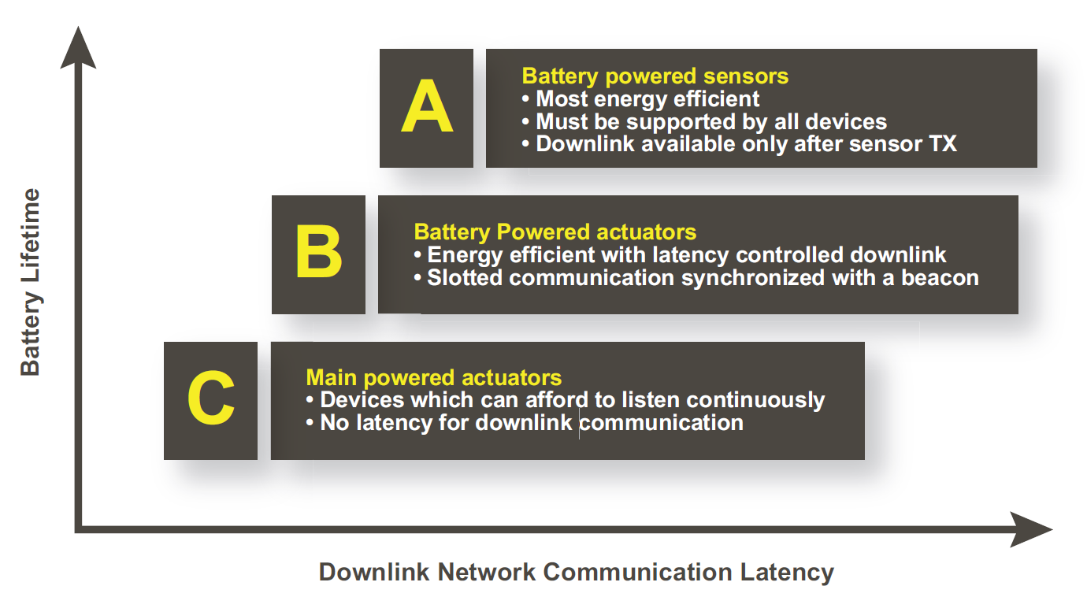

# 6 Market information

The LoRa Alliance™, the consortium maintaining the LoRaWAN™ protocol, has attracted more than 450 members after two years of existence. Its members include mobile network operators, sensor and gateway manufacturers, chipset and module manufacturers, large enterprises, network management services, and application software providers. The LoRaWAN™ protocol is open in a twofold sense:

1. Every developer, network provider, equipment manufacturer etc. can get it by simply sending an email request to <mailto:admin@mail.lora-alliance.org>;
2. Every developer, network provider, equipment manufacturer etc. can become a member of the Lo-Ra Alliance™ and contribute to the evolution of the LoRaWAN™ protocol (and related test and certification procedures).

While the LoRa Alliance™ defines the LoRaWAN™ specification and certifies products, it does not dictate how service providers should deploy LPWAN-CSS networks and price services. This open ecosystem approach creates flexibility for service providers and enables a variety of business models to flourish. For example, service providers currently offer LPWAN-CSS connectivity services based on monthly subscriptions for network server use, number of messages sent, number of devices connected, or according to time of day usage. Furthermore, the LoRaWAN™ protocol can be used to implement

1. a private (closed) network: an entity (e.g., a company in its own premises, a municipality, etc.) can deploy all of the elements of **Figure 1** and run the network
2. a public (open) network: an entity (a network provider) can deploy all of the elements of **Figure 1** except the end nodes and offer, as mentioned above, the connectivity to anyone intending to deploy sensor/actuator end nodes and related applications for different purposes.

The map below represents only the announced open networks that are available for end users to benefit from the connectivity. For the purpose of this document, one can see that in the vast of the countries members of CEPT there are already public (open) networks available.

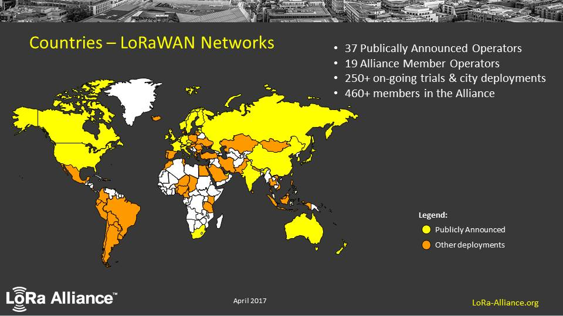

Figure 3 – LPWAN-CSS networks worldwide coverage map, April 2017 (source LoRa Alliance™)

LPWAN-CSS technology is used for variety of applications that can be classified in different verticals. The figure below is a list of the main verticals and applications that are currently foreseen for these networks.

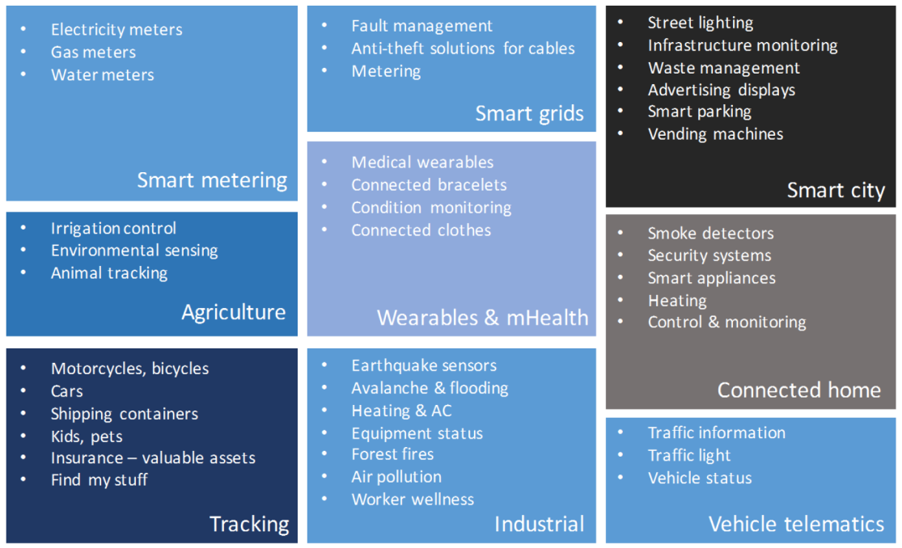

Figure 4 – Main verticals and use cases (source LoRa Alliance™)

Overall the proportion of indoor devices varies from 30% to 70%, depending on the specific market. Indoor meters and smart building devices represent a large number of use cases. And outdoor parking sensors or tracking devices are also used for a large portion of the applications.

After having described the main applications of LPWAN-CSS technology, the market forecasts are extremely positive for the LPWAN-CSS technology:

In 2021 the following is predicted:

* 1.4 billion USD revenues from LPWA-CSS module shipping, the majority of which, with equal sharing, in Europe, North America and Asia-Pacific.
* The sales of LPWA modules is projected to have a volume almost equal to the sum of the module’s sales from other LPWA technologies (including LTE CATM1, LTE CATNB1 and SigFox)

# 7 Technical information

## 7.1 Detailed technical description

### 7.1.1 LPWA-CSS signals

The radio signals used by both the end nodes and the gateway employ the same modulation and spreading. They are chirp spread spectrum signals parametrized by the Spreading Factor (SF), a parameter ranging from 7 to 12 controlling the slope and the length in time of the signals. As a useful convention in the context of LPWAN-CSS systems and networks, the term SF index represents the of the actual spreading factor computed according to the LoRaWAN Specifications (see [i.1]). So, the actual spreading factor, according to the LoRaWAN Specifications range from 128 (SF=7) to 4096 (SF=12).

In Figure 5 an example of the instantaneous frequency of a LPWAN-CSS radio signal with SF=7 in a bandwidth of 125kHz is given: we observe the frequency is sweeping with respect to the centre of the operating channel (assumed to 0 for simplicity) from -62.5 kHz to 62.5 kHz. The channels are separated by 200 kHz.



Figure 5: An example of a LPWAN-CSS signal

In the following Table, we see the influence of the SF parameter which is basically stretching in the time domain the signal represented in Figure 5, doubling the duration of the each sweep at every step increase of the SF.

|  |  |  |  |  |  |  |
| --- | --- | --- | --- | --- | --- | --- |
| Spreading Factor index | 7 | 8 | 9 | 10 | 11 | 12 |
| Chirp duration | 1 ms | 2 ms | 4 ms | 8 ms | 16 ms | 32 ms |

Table 1: Chirp duration as a function of the Spreading Factor

The LPWAN-CSS signals are used in asynchronous manner over the air, i.e., the end nodes transmit uncoordinated between themselves and the gateways. One then may think that the collisions on air might lead to the impossibility of correct reception of most of the signals. However, a fundamental feature of the LPWAN-CSS signals is that any two LPWAN-CSS signals have a certain isolation factor if they have different spreading factors. ~~The LPWAN-CSS signals with different spreading factors would be perfectly isolated provided a “victim” LPWAN-CSS signal with a spreading factor~~ *~~i~~* ~~get superimposed in time by an “interferer” LPWAN-CSS signal with a spreading factor~~ *~~j,~~* ~~where~~ *~~i≠j~~*~~,. In such case the “victim” signal could be perfectly demodulated as if the other signal was not present. As a matter of fact, the actual “victim” LPWAN-CSS signal can be demodulated i.e., the “interferer” signal with different spreading factor has a negligible effect on the demodulation performances for the “victim” signal.~~ The LPWAN-CSS signals with different spreading factors, if superimposed in time, can be demodulated provided there is a sufficient power margin between the victim and the interferer.

The LPWAN-CSS packet of data consists of a preamble, a PHY (Physical Layer) header and an actual payload. The preamble is used for detection and synchronisation purposes, the PHY header describes the payload length which ranges from 13 to 255 bytes. Indeed, the minimum size of a LoRaWAN™ physical payload is 13 bytes. A 16 bits CRC is also transmitted. The channel encoding for the packet is a (5,4) parity code. In Table 2 the time overhead (i.e., the time used for the transmission of the preamble, the PHY header and the CRC) and the payload data rate (parity code included) are shown as function of the spreading factor

|  |  |  |
| --- | --- | --- |
| SF index | Payload Data rate | Time overhead |
| 7 | 5.5 kbps | 40 ms |
| 8 | 3.1 kbps | 80 ms |
| 9 | 1.8 kbps | 150 ms |
| 10 | 0.98 kbps | 280 ms |
| 11 | 0.44 kbps | 570 ms |
| 12 | 0.25 kbps | 1100 ms |

Table 2: Payload Data Rate and Time overhead as a function of the SF index

The LPWAN-CSS modulation belongs to the spread-spectrum class. As such it encodes a low data rate bit stream onto a comparatively wide occupied bandwidth. Similarly, there is no direct relationship between occupied bandwidth and actual bit rate, the bit rate can be changed over a wide range without modifying the spectrum shape. The transmitted LPWAN-CSS signal is constant envelope. This means that it can be transmitted using a simple and very power efficient radio architecture where the RF Phase locked loop output directly drives a saturated power amplifier. See the Annex E for resulting modulated spectrum.

## 7.2 Technical parameters and implications on spectrum

### 7.2.1 General technical parameters

In the deployment in Europe of a LPWAN-CSS network (although the network operator can in principle choose a different channel line-up) a set of channels are defined by the LoRaWAN™ protocol both for the end devices and the gateways. As far as the terminology is concerned, in the LoRaWAN™ protocol a channel is a triplet [center frequency, occupied bandwidth, SF for LPWAN-CSS or FSK] while the data rate (DR) designator is reference to a combination of two values [SF for LPWAN-CSS or FSK, occupied bandwidth]. It is remarked that the LoRaWAN™ protocol allows devices to make use of the plain FSK modulation with bit rate of 50 kbits/s

For the European region, the following set of data rates are allowed by the LoRaWAN™ protocol:

|  |  |  |
| --- | --- | --- |
| DR | Configuration (SF for LPWAN-CSS or FSK, occupied bandwidth) | bit rate (bit/s) |
| 0 | LPWAN-CSS: SF12 / 125 kHz | 250 |
| 1 | LPWAN-CSS: SF11 / 125 kHz | 440 |
| 2 | LPWAN-CSS: SF10 / 125 kHz | 980 |
| 3 | LPWAN-CSS: SF9 / 125 kHz | 1760 |
| 4 | LPWAN-CSS: SF8 / 125 kHz | 3125 |
| 5 | LPWAN-CSS: SF7 / 125 kHz | 5470 |
| 6 | LPWAN-CSS: SF7 / 250 kHz | 11000 |
| 7 | FSK | 50000 |

Table 3 : data rates allowed by the LoRaWAN™ protocol

The central frequencies of the LPWAN-CSS (LoRaWAN™) signals are in Europe as following (as an example), the occupied bandwidth being 125kHz:

1. 867.1 MHz (1% duty cycle, uplink and downlink)
2. 867.3 MHz (1% duty cycle, uplink and downlink)
3. 867.5 MHz (1% duty cycle, uplink and downlink)
4. 867.7 MHz (1% duty cycle, uplink and downlink)
5. 867.9 MHz (1% duty cycle, uplink and downlink)
6. 868.1 MHz (1% duty cycle, uplink and downlink)
7. 868.3 MHz (1% duty cycle, uplink and downlink)
8. 868.5 MHz (1% duty cycle, uplink and downlink)
9. 869.525 MHz (downlink only, 10% duty cycle)

Three channels (channels 6, 7 and 8, see Table 4) are the so called “*default channels”* and are to be implemented by every end node.

|  |  |  |  |
| --- | --- | --- | --- |
| Modulation | Bandwidth [kHz] | Central Channel Frequency [MHz] | LPWAN-CSS DR  / Bitrate |
| LPWAN-CSS | 125 | 868.10  868.30  868.50 | DR0 – DR5  / 0.3-5 kbps |

Table 4: 863-870 MHz Default Channel List

The use of the *default channel* is mandatory for end nodes and gateway, as said before, and the use of the different Data Rates (DR) is regulated by the Adaptive Data Rate described above.

Furthermore, apart from the 3 default channels, the network server can instruct the gateways and the end nodes to use up to 5 additional channels through a specific protocol command. For each additional channel the bandwidth is 125 kHz and the data rates that can be employed are DR0 to DR5.

The table below shows the typical configuration for antenna heights for gateways and end nodes.

|  |  |  |
| --- | --- | --- |
| Equipment | Typical antenna height (indoor) | Typical antenna height (Outdoor) |
| End nodes (all with integrated antenna) | * 1.5 m (80%) * 9 m (9%) * 30 m (1%) | * 1,5 m (10 %) |
| Gateway | * 1,5 m (10%) * 9 m (10%)   (indoor gateways have integrated internal antennae) | * 25 m (75%) * 40 m (5%) |

Table 5 – typical antenna heights; in brackets the percentage of Devices and Gateways at the respective antenna height

The table below presents the range of coverage radius for LPWAN-CSS outdoor gateways. This radius strongly depends on a number of factors such as antenna height, terrain, buildings height and density, location of the devices.

|  |  |
| --- | --- |
| Environment | Typical coverage radius |
| Urban | 1 km |
| Rural | 10 km |

Table 6 – typical coverage radius

In **Figure 6** is a simulation result showing the impact of gateway density on the realistic distribution of used data rates among end nodes which populate an LPWAN-CSS network. The assumptions used were a square grid gateways layout, small/medium city Hata model [i.2] for attenuation, Rayleigh fading, and uniformly distributed additional shadow margin between 0 and 40dB to account for end-nodes positions from outdoor to deep indoor.

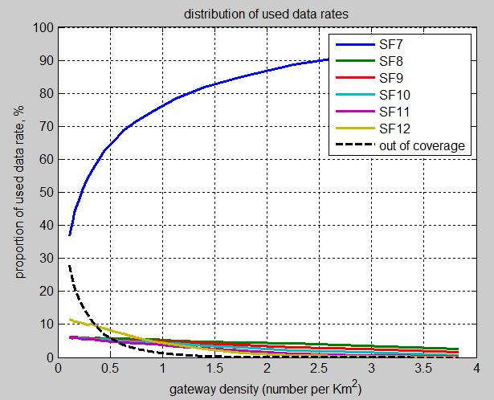

**Figure 6: data rates distribution as a function of gateway density**

The SF12 is more used than SF11 because this is the lowest available data rate: this shows the ADR algorithm uses some margin.

The adaptive data rate here assumes that the devices are static so that after a few messages they can be controlled to the target data rate. SF7/8/9/10/11/12 have to be considered as index of data rate, with a fixed signal bandwidth of 125kHz. SF7 data rate is roughly 20 times faster than SF12 data rate, which explains why the average duty cycle reduces a lot as network density increases.

According to the above assumptions, the results show that most of the end nodes are using SF7. This is because in the above-mentioned simulation scenario, there is a mix of deep indoor, indoor and outdoor nodes, due to the fact that it is assumed a uniform distribution of the attenuation due to building penetration losses ranging from 0 to 40 dB. This would change if we considered indoor and deep indoor only nodes: in this case, the end nodes using SF7 would only become dominant when the density of gateways is high.

It may look like a strong assumption that devices are static, and that adaptive data rate is not possible for moving devices. However, the vast majority of moving devices will be outdoor, so that - due to better propagation conditions with respect to the underground and indoor end nodes – they are very likely to use the smallest SF, i.e., SF 7. This is another reason why the big proportion of SF7 end nodes: outdoor end nodes which do not use adaptive data rate but they do not need it.

As the density of gateways is varied, the resulting average message duration is computed and reported below on **Figure 7**

**Figure 7: average time on air [s] per message as a function of the number of gateways per square kilometre**

The following table shows the T\_on / (T\_on+T\_off) for end nodes and gateways, for typical applications

|  |  |  |  |  |
| --- | --- | --- | --- | --- |
| **Year** | **End nodes** T\_on / (T\_on+T\_off) | **End node density per square kilometre** | **Gateway** T\_on / (T\_on+T\_off) **per channel (there are at least 3+1 channels)** | **Gateway density** **per square kilometre** |
| 2017 | 0,0160% | 360 | 0.7% | 0.5 |
| 2023 | 0,0045% | 5582 | 0.5% | 3.5 |

**Table 7 –** T\_on / (T\_on+T\_off) **per square kilometre LPWAN-CSS** , for typical applications

We base our derivations on the peculiarity of the LPWAN CSS Systems called “network densification”: a network operator seeing an increasing number of connections will increase the gateways density and this is counterbalancing the global time on air since, as a consequence of an increase of gateways, the time on air is decreasing (because the devices use a lower spreading factor).

As mentioned above the number of channels used to deploy a LPWAN CSS system are usually 9 (8 uplink/downlink and 1 downlink); actually a gateway can demodulate 8 channels. The minimum number of channels needed to deploy a LPWAN CSS system is 4 (3 uplink/downlink and 1 downlink). The uplink communications are only low power; the downlink can use both low power and high power channels; the network defines the power based on the channel frequency (according the regulations).

If more than one operator (let’s suppose for simplicity two) is operating in the same geographical area two situations can arise:

- (competing networks) 4 out 9 channels are in common (including the high power one in downlink only) between e.g., two networks, the others channels are chosen in a independent way by the two networks;

- (cooperative networks): all channels are the same between the two networks, roaming between network servers handle the packets to/from different networks: if a packet is received by a network to which it is not pertaining, the packet is forwarded to the network server of the other network.

For sake of clarity, no exclusivity/protection of any channels is needed; this means no specific frequency planning or specific re-use principles are applied.

The above mentioned results of **Figure 7** and **Table 7** already include the traffic of potential multiple networks running in parallel.

### 7.2.2 Status of technical parameters

#### 7.2.2.1 Current ITU and European Common Allocations

#### 7.2.2.2 Sharing and compatibility studies (if any) already available

In clause 7.3.1 of ETSI TR 103 435 V1.1.1 an overview of existing studies are provided. Since the publication of TR 103 435 the ECC Reports 246 and 261 where published.

#### 7.2.2.3 Sharing and compatibility issues still to be considered

It is expected that CEPT will perform the usual compatibility and sharing studies as for any new technology.

Annex C provides some input.

### 7.2.2 Transmitter parameters

#### 7.2.2.1 Transmitter Output Power / Radiated Power

The end nodes transmit (always according to the limitations of the bands in which they work) with a power of 5mW or 25mW; the gateways transmit with power equal to 5mW, 25mW or 500mW (always according to the limitations of the bands in which they work). The end nodes operate according to the duty cycle restriction in each band or according to the LBT/AFA (see section 7.2.4 “Channel Access Parameters”) policy, while the gateways can operate only according to the duty cycle limitations.

Adaptive Power Control can also be applied to the transmitted signal power of the end nodes in Uplink and the gateways in Downlink, based on network indications. Similarly to the Adaptive Data Rate, the Network server can impose to an end device to reduce its output power (through a Downlink control command) based on the signal quality information of previous received packets in Uplink. Same is valid for the Gateways, where the Network Server can reduce the Downlink signal power based on the signal quality of previous packets received from an end node in Uplink. Moreover for Uplink frames received by multiple GW, the network server will chose to perform a downlink transmission using the gateway that has received the signal with the best quality ( called “assigned downlink gateway”), so that a lower output power can be used.

For the uplink, based on previous emissions signal quality (i.e., signal level computed by the assigned downlink gateway) the network server reviews the transmitted output power of the end node via a protocol command: if the resulting margin with respect to the sensitivity of the gateway is higher than 10dB, then the output power of the end nodes is requested to be reduced, with a 2 dB granularity, ranging from 14dBm to 0dBm.

For the downlink, based on previous emissions signal quality (i.e., signal level computed by the assigned downlink gateway) the network server reviews the transmitted output power of the assigned gateway: if the resulting margin with respect to the sensitivity of the gateway is higher than 10dB, then the output power of the assigned gateway is reduced, with a 3 dB granularity, ranging from 27dBm to 3dBm on 500mW downlink and from 14dBm to 3dBm on 25mW downlink.

It is noted that the RX signal level is based on the uplink signal received between 1s and 5 s before the transmission.

#### 7.2.2.1.1 Antenna Characteristics

The end-device uses an omnidirectional antenna which gain is 0 dBi, equivalent to -2.15 dBd.

The gateway uses an omnidirectional antenna which gain is 5.5 dBi, equivalent to 3.35 dBd.

#### 7.2.2.2 Operating Frequency

The bands in which LPWAN CSS systems could operate are for example the following mostly harmonized SRD bands, see ERC Recommendation 70-03 (ref [3]):

1. 863-870 MHz (h1.3)
2. 868-868.6 MHz (h1.4)
3. 868.7-869.2 MHz (h1.5)
4. 869.4-869.65 MHz (h1.6)
5. 869.7-870 MHz (h1.7)
6. 870-876 MHz (h2)
7. 915-921 MHz (h3)

LoRaWAN™ system can withstand frequency tolerances of typically ±25% of the LPWAN-CSS occupied bandwidth and still maintain a 10% PER link.

#### 7.2.2.3 Out of band emissions

The following tables are showing the out of band emissions. The centre frequencies are not specified, actually the centre frequency can be any frequency compatible with the spectrum requests in Paragraph 8.

|  |  |
| --- | --- |
| **F-fc (kHz)** | **Level e.r.p** |
| ± 62.5 | 14 dBm/125kHz |
| ± 125 | -45 dBm/1kHz |
| ± 250 | -55 dBm/1kHz |
| ± 500 | -52 dBm/100kHz |
| ± 6000 | -52 dBm/100kHz |

Table 8 Downlink (gateway) and Uplink (End-node) emission level for 25mW ERP

|  |  |
| --- | --- |
| **F-fc (kHz)** | **Level e.r.p** |
| ± 62.5 | 27 dBm/125kHz |
| ± 125 | -32 dBm/1kHz |
| ± 250 | -42 dBm/1kHz |
| ± 500 | -39 dBm/100kHz |
| ± 6000 | -39 dBm/100kHz |

Table 9 Downlink (gateway) emission level for 500mW ERP

The results of OOB measurements are shown in Annex E.

#### 7.2.2.4 Spurious emissions

Measurements of the spurious emissions for a LPWAN-CSS signal of 125 kHz bandwidth, centered at 869.525 MHz with a power of 27 dBm (worst case) are shown below (the limits of ERC Recommendation 74-01 are provided with red lines in the below figures).

First the emissions below 1 GHz are addressed in Figure 8 and 9 (the measurements are done with a notch filter tuned to the carrier frequency for any frequency below 1 GHz).

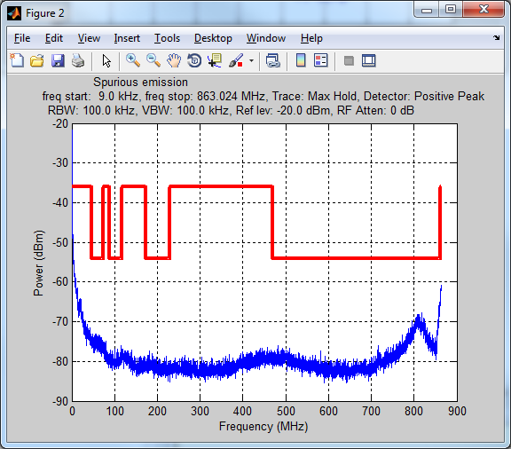

Figure 8: 125 kHz, 869.525 MHz, 27 dBm Spurious emission (conducted), Frequency below 1 GHz – 1st part

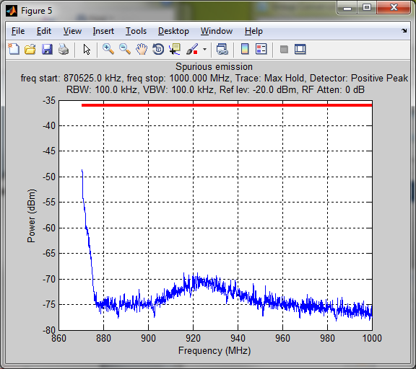

Figure 9: 125 kHz, 869.525 MHz, 27 dBm Spurious emission (conducted), Frequency below 1 GHz – 2nd part

In the following figure spurious emission measurements done in the region above 1GHz are shown; the measurements has been done using a high pass filter (Fc = 1.2GHz) for frequency above 1 GHz.

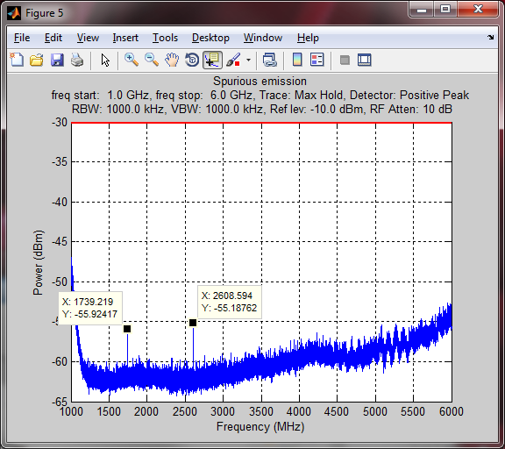

Figure 10: 125 kHz, 869.525 MHz, 27 dBm Spurious emission (conducted), Frequency above 1 GHz

### 7.2.3 Receiver parameters

#### 7.2.3.1 Sensitivity

Table 10 gives the in-band required SNR to achieve the demodulation with a 10% Packet error rate with coding rate of 4/5, for 20 bytes payload and different SF for LPWAN-CSS signals i.e. both for the end node and the gateway.

Table 10 indicates as well the sensitivity of a LPWAN-CSS receiver, both for the end node and the gateway, taking into account the equipment noise factor (NF).

We assume, as usual, the thermal noise power spectral density (kTB) to be -174dBm/Hz in a 50 Ohm load.

In that case for a given SF a LPWAN-CSS receiver would have a sensitivity of:

where is the sensitivity at the spreading factor *SF*, *BW* is the bandwidth (125 or 250 kHz) and is the SNR to achieve a demodulation with a 10% Packet error rate with coding rate of 4/5, for 20 bytes payload at spreading factor *SF*, according to Table 10

For example, for a LPWAN-CSS receiver which exhibits a noise factor of 7 dB, for a bandwidth of 125kHz, the sensitivity using SF12 will be:

A low power end node chip typically exhibits a noise factor of 5 to 7dB depending on the external impedance matching components. A gateway front-end typically exhibits a noise factor of 3dB to 7 dB.

The sensitivity of a receiver is normally taken as the minimum input signal (Smin) required to produce an output signal with a specific signal-to-noise (S/N) ratio. S/N is a required minimum ratio, if N is increased, then S is also be increased to maintain the S/N ratio.  Considering the fact that S/N is negative for this system, the most appropriate protection factor is the C/(I+N); indeed, when the interferer is below the thermal noise level the receiver sensitivity is not significantly degraded, while when the interferer is above the noise floor, it becomes predominant and it degrades the receiver sensitivity.

|  |  |  |  |  |  |
| --- | --- | --- | --- | --- | --- |
| SF index | Spreading factor | Data rate | C/(I+N) (dB) | Sensitivity @3dB NF w/  N=-120dBm | Sensitivity @7dB NF w/  N=-116dBm |
| 7 | 128 | 5.5 Kbps | -8.0 | -128.0 dBm | -124.0 dBm |
| 8 | 256 | 3.1 Kbps | -10.8 | -130.8 dBm | -126.8 dBm |
| 9 | 512 | 1.8 Kbps | -13.6 | -133.6 dBm | -129.6 dBm |
| 10 | 1024 | 0.98 Kbps | -16.3 | -136.3 dBm | -132.3 dBm |
| 11 | 2048 | 0.44 Kbps | -19.2 | -139.2 dBm | -135.2 dBm |
| 12 | 4096 | 0.25 Kbps | -21.9 | -141.9 dBm | -137.9 dBm |

Table 10 – Receiver sensitivity in a 125 kHz bandwidth (considering an AWGN channel) for different SF and NF

#### 7.2.3.2 Adjacent channel rejection

In general, in this document, the wanted signal level is equivalent to the sensitivity (as reported in Table 10, both the gateways and the end nodes) plus 2 dB of margin. As an example, for the end device SF=7 case the wanted signal level considered is -124+2=-122 dBm. If the wanted received signal is higher than this value the rejection scales accordingly.

The adjacent channel rejection (victim LoRaWAN signal at -122 dBm versus adjacent LoRaWAN channel) at 200kHz offset is -87 dBm, at 400 kHz is -74 dBm. It is noted that the center frequencies of the different LPWAN-CSS channels are spaced of 200 kHz. Annex D is providing additional information on pulsed interference.

#### 7.2.3.3 Blocking

In Figure 11 the blocking performance of a continuous wave interferer by a gateway is shown (we recall that the definition of wanted signal is provided in the previous paragraph). We remark that similar figures apply to end nodes and that the transmission and reception of the LPWAN-CSS signal is symmetrical between gateways and end nodes. As a matter of fact, the uplink and downlink link budgets are made symmetrical by a proper choice of the settings like e.g, the antenna gain.

Note that the figures provided in this and the above paragraph do not take into account possible external filters (e.g. SAW or cavity) which are typically applied to gateways and optionally to end nodes

kHz

Figure 11: Continuous wave interferer rejection; the wanted signal in the figure is an example of the case of an SF7 signal at -122 dBm received by the end node.

|  |  |
| --- | --- |
| CW (aggressor) frequency offset from wanted LoraWAN (victim) center frequency (kHz) | Rejection (dBm) |
| ± 62.5 | -117 |
| ± 125 | -107 |
| ± 250 | -82 |
| ± 500 | -67 |
| ± 1000 | -57 |
| ± 2000 | -52 |
| ± 5000 | -47 |
| ± 6000 | -42 |

Table 11: Interferer rejection

In the following some measurement result examples are reported to provide insight on the blocking performance of some real gateways and end nodes. The measurement setup uses two signal generators: one for the wanted signal, the other one for the interferer. Useful and interferer signals are summed in a power combiner to be injected in the device under test. Attenuators inserted on the combiner ports allow reducing the mutual interference between both signal generators.

The Figure 12 shows the blocking robustness of a gateway reference design to a continuous carrier wave from -10 to +10 MHz for all the spreading factors. A refinement is performed around the carrier frequency to evaluate the in-band robustness (see Figure 13). The results of this measurement is the blocking level which correspond to the interferer level causing a PER of 50%.

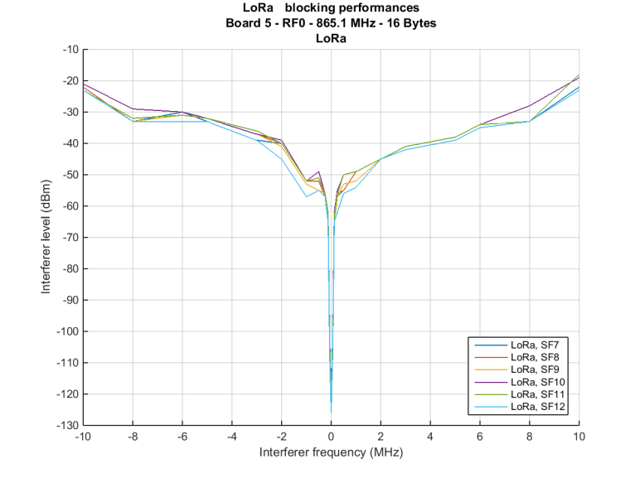

Figure 12: LPWAN-CSS gateway, wideband blocking performances for all the spreading factors

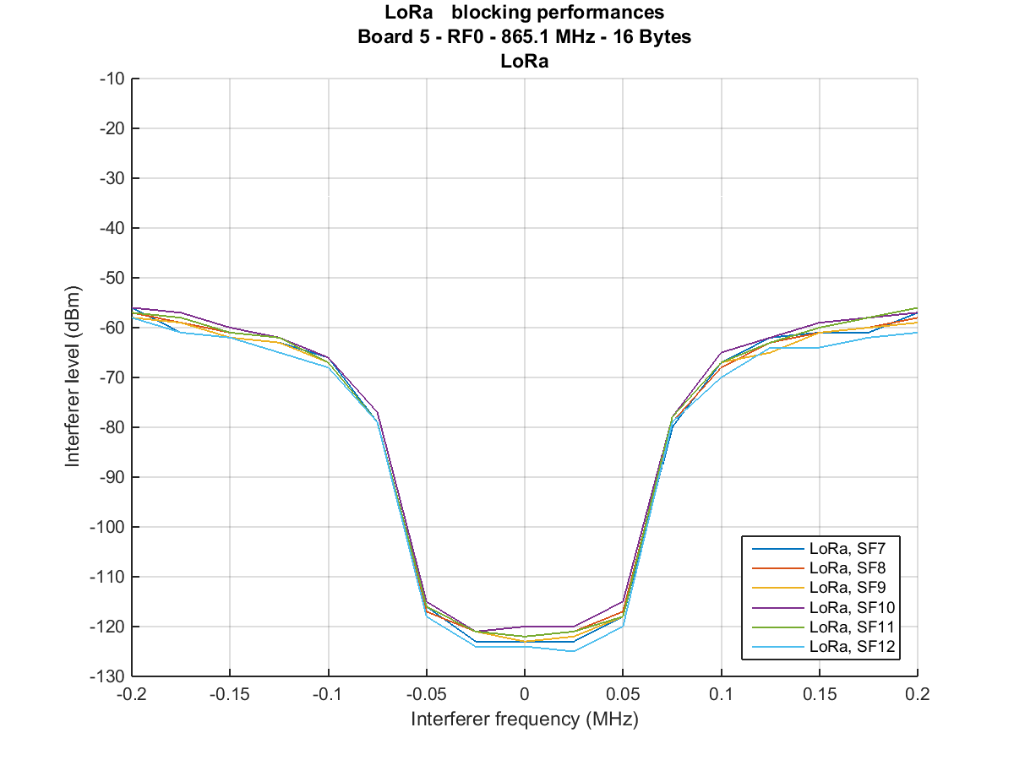

Figure 13: LPWAN-CSS gateway, In-band blocking performances

The measurement is reproduced on an End-Device evaluation board; the results are shown in Figure 14 and Figure 15. We remark that similar figures apply to end nodes and that the transmission and reception of the LPWAN-CSS signal is symmetrical between gateways and end nodes. As a matter of fact, the uplink and downlink link budgets are made symmetrical by a proper choice of the settings like e.g, the antenna gain.

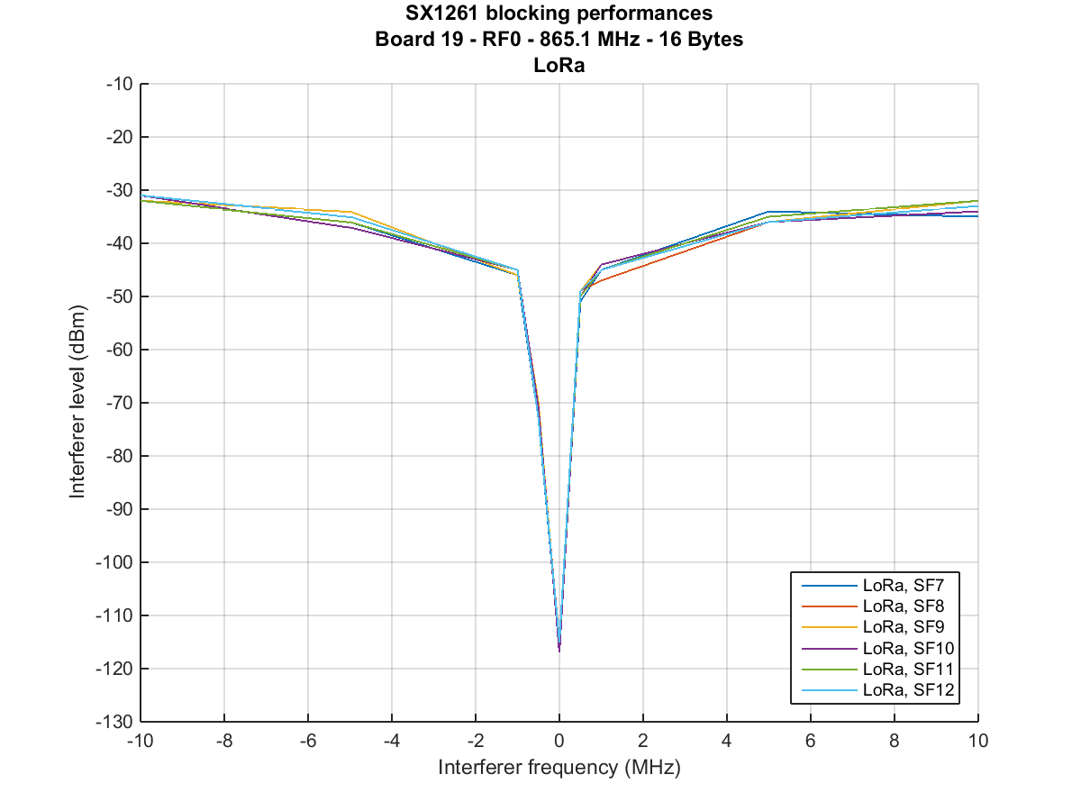

Figure 14: End-device, wideband blocking performances for all the SF

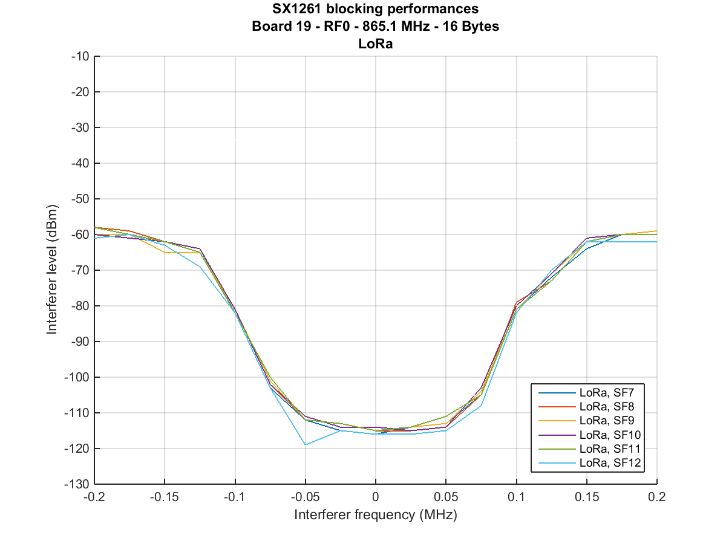

Figure 15: End-device, In-band blocking performances

#### 7.2.3.4 Intermodulation response rejection

The Input third-order Intercept Point or IIP3 is a commonly accepted parameter allowing to measure the receiver linearity. The LoRaWAN™ gateway front-end provides a typical IIP3 of -15 dBm. For the end nodes, the typical IIP3 value is -12.5 dBm. These measurements consider on offset up to 1 MHz between the wanted and the closer interferer signal.

### 7.2.4 Channel access parameters

The end nodes perform a Polite Spectrum Access by adopting, as mandated by LoRaWAN™, only the relevant (according to the European standards) duty cycle or LBT/AFA. It is left to the network operator to select which policy to adopt and the detailed arrangements.

The gateway, as mandated by LoRaWAN™, uses a limited duty cycle policy.

The channel access for the end nodes is described in LoRaWAN™ [i.1] and is basically an Aloha access scheme. A retransmission back-off scheme is mandatory for all end nodes; it is detailed in the LoRaWAN™ protocol [i.1, paragraph 7]. It is adopted for the usual reasons, i.e., to avoid catastrophic re-transmissions in case of acknowledged messages or unexpected events (including a network bootstrap after an outage).

In the following the timing for the uplink and downlink transmissions are presented. The reader is invited to refer to Subsection 5.2 for the definitions of Class A, B and C end nodes and their behaviour. It is noted that, referring to Figure 16, in the RX1 receive window gateway’s transmissions are limited to 25mW channels only, while – when necessary – in the RX2 gateway’s transmissions can occur in 500mW channels. In general, in 20% of the cases RX1 window only is used, while in the remaining downlink transmission RX2 window is used.



Figure 16: Class A end nodes timing for uplink and downlink transmission

For class A the timings of the transmission and reception operation are shown in Figure 16. After an asynchronous transmission (box “Transmit”) with a certain spreading factor (the choice of the spreading factor is explained in section 5.2.4 Adaptive Data Rate) in a certain radio channel (the available spectrum is divided in different channels 125 kHz, or 250 kHz wide and the LoRaWAN™ protocol provides for a unique identification of them) the receiver opens a first window (the minimum time for the receiver to stay on from the beginning of the first window is set by the LoRaWAN™ protocol to be at least the time required by the radio of the end node to detect if a preamble if present) in a channel and using a SF to decode the received signal which are a function of the channel and SF used in the uplink. A second receive window is mandated by the LoRaWAN™ protocol with a completely similar behaviour for the end node, except from the fact that the SF and the channel are not a function of the uplink SF and channel but are configurable via LoRaWAN™ protocol commands. At the very first transmission a default configuration depending on the region (Europe has its own i.e., the one based on the default channels) is used.



Figure 17: Class B end nodes timing for uplink and downlink transmissions

For Class B operation (see Figure 17) all of the gateways need be time synchronized and each one must emit a beacon signal used by each end device to synchronize with the network. The beacon may include other information intended for upper layers (e.g., MAC layer) of the end nodes. According to the LoRaWAN™ protocol, the MAC layers – both at the end node side and the Network server side – select a period and an offset for the so-called “ping” slots i.e., the time slots where the end node is opening the radio receiver for 30ms in order to see if there is a preamble of a data packet coming from the network. In that case, the node continues for the time needed to the complete decoding of the packet sent from the network. These “ping” slots are periodic, the period being *PING\_PERIOD* and their offset from the beacon is called *PingOffset*. At the end of each *PING\_PERIOD* a new *PingOffset* is computed by both the end node and the network server, in order to randomize the allocation of the end nodes and avoid e.g., periodic interference. Although the additional power consumption for a class B node is limited with respect to a Class A node to the time needed to detect the possible preambles in the ping slots, there are some additional tasks to be performed by an end node when in class B mode: the end node in this case must keep the network server informed about the gateway from which it is hearing the beacon with best quality. That will be the Gateway involved in the downlink transmission in case a packet needs to be sent form the Network Server. This gateway may of course change because of changing propagation conditions or because the end-node is moving.

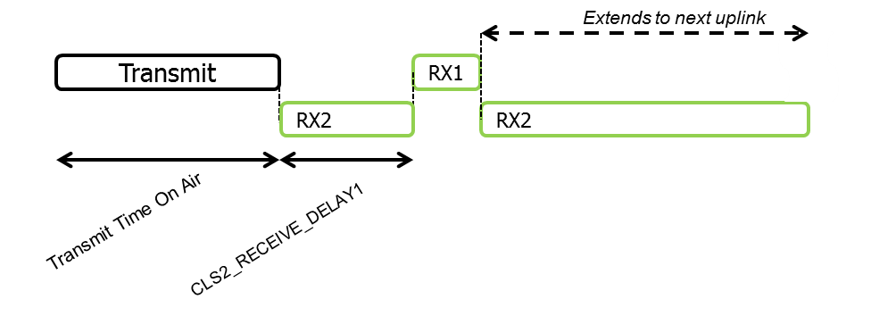

Figure 18: Class C end nodes timing for uplink and downlink transmission

The timing of the operation of class C is depicted in Figure 18. A node operating in Class C mode is always listening to a radio channel with a certain SF for packets coming from the network server, which sends the packets in a totally asynchronous manner. When a node operating in class C needs to send a packet to the network, it operates in way similar to the class A end end-nodes: it send the packets (“*transmit*” in Figure 18) and then continue listening in the usual channel and SF (“*RX2*” in Figure 18), switching to the equivalent of the first receive window of class A after *CLS2\_RECEIVE\_DELAY1* seconds. At the end of this receive window the end node returns to listening to the same radio channel and SF as before, until the transmission of the next packet. As one can see the power consumption of a Class C node is higher than both Class A and Class B nodes. Class C nodes are ideally suited for sensors and – even more – for actuators nodes attached to the main power

Two categories of end nodes can coexist on a LPWAN network:

* Device Duty cycle limited
* Device that use LBT/AFA algorithm

Below are LBT/AFA algorithm details:

* Clear Channel Assessment (CCA) threshold = -83 dBm
* The minimum CCA interval employed: 5ms
* The maximum dead time: 5ms
* The minimum transmission off time on the same operating frequency, Toff min : 2 sec

Adaptive Frequency Agility is used, i.e. when a channel is detected as occupied a retransmission is tried on a different channel (one of the 8 channels defined per end device) in a random manner. A CCA is performed at any new retry. After 8 retries the communication is aborted waiting for next event.

## 7.3 Information on relevant standard(s)

For the MAC layer and for many aspects of the upper layers of the LPWAN-CSS systems the reference is the LoRaWAN™ Specification  [i.1].

# 8 Radio spectrum request and justification

The frequency bands in which LPWAN CSS systems are able to operate are the following mostly harmonized SRD bands.,

1. 863-870 MHz (h1.3 of ERC REC 70-03 )
2. 868-868.6 MHz (h1.4 of ERC REC 70-03)
3. 868.7-869.2 MHz (h1.5 of ERC REC 70-03 and subband 48 of EC decision 2017/1483)
4. 869.4-869.65 MHz (h1.6 of ERC REC 70-03 and subband 54 of EC decision 2017/1483)
5. 869.7-870 MHz (h1.7 of ERC REC 70-03 and subband 56b of EC decision 2017/1483)
6. 870-876 MHz (h2 of ERC REC 70-03)
7. 915-921 MHz (h3 of ERC REC 70-03)
8. 863-868 MHz (Sub-band 84 of EC decision 2017/1483)
9. 865- 868MHz (Sub-band 47 of EC decision 2017/1483)

# 9 Regulations

## 9.1 Current regulations

The table below is extracted from the ERC Recommendation 70-03, Annex 1, regarding the regulation for non-specific SRDs operating in 800 MHz and 900 MHz bands.

|  |  |  |  |
| --- | --- | --- | --- |
| **Frequency Band** | | **Power / Magnetic Field** | **Spectrum access and mitigation requirements** |
| **h1.1** | 863-870 MHz  (notes 3 and 4) | 25 mW e.r.p. | ≤ 0.1% duty cycle or LBT  (notes 1 and 5) |
| **h1.2** | 863-870 MHz  (notes 3 and 4) | 25 mW e.r.p.  Power density  - 4.5 dBm/100 kHz  (note 7) | ≤ 0.1% duty cycle  or LBT+AFA  (notes 1, 5 and 6) |
| **h1.3** | 863-870 MHz  (notes 3 and 4) | 25 mW e.r.p. | ≤ 0.1% duty cycle or LBT+AFA  (notes 1 and 5) |
| **h1.4** | 868.000-868.600 MHz  (note 4) | 25 mW e.r.p. | ≤ 1% duty cycle or LBT+AFA  (note 1) |
| **h1.5** | 868.700-869.200 MHz  (note 4) | 25 mW e.r.p. | ≤ 0.1% duty cycle or LBT+AFA  (note 1) |
| **h1.6** | 869.400-869.650 MHz | 500 mW e.r.p. | ≤ 10% duty cycle or LBT+AFA  (note 1) |
| **h1.7** | 869.700-870.000 MHz  (note 11) | 5 mW e.r.p.  25 mW e.r.p. | No requirement  ≤1% duty cycle or LBT+AFA  (note 1) |
| **h2** | 870-876 MHz | 25 mW e.r.p. | ≤ 0.1% duty cycle  For ER-GSM protection  (873-876 MHz, where applicable), the duty cycle is limited to ≤ 0.01% and limited to a maximum transmit on-time of 5ms/1s |
| **h3** | 915-921 MHz | 25 mW e.r.p. | ≤ 0.1% duty cycle  For ER-GSM protection  (918-921 MHz, where applicable), the duty cycle is limited to ≤ 0.01% and limited to a maximum transmit on-time of 5ms/1s |

Table 12 Extract from the ERC Recommendation 70-03, Annex 1

The table below is extracted from the COMMISSION IMPLEMENTING DECISION (EU) 2017/1483, Official Journal of the European Union 18-8-2017.

|  |  |  |  |  |
| --- | --- | --- | --- | --- |
| **Band no** | **Frequency band [i]** | **Category of short-range devices [ii]** | **Transmit power limit/field strength limit/power density limit [iii]** | **Additional parameters (channelling and/or channel access and occupation rules) [iv]** |
| 84 | 863-868 MHz | Wideband data transmission devices [16] | 25 mW e.r.p. | Techniques to access spectrum and mitigate interference that provide at least equivalent performance to the techniques described in harmonised standards adopted under Directive 2014/53/EU must be used.  Bandwidth: ≤ 1 MHz.  Duty cycle [vi]: ≤ 10 % for network access points [26]  Duty cycle [vi]: ≤ 2,8 % otherwise |
| 47 | 865-868 MHz | Non-specific short-range devices [3] | 25 mW e.r.p. | Techniques to access spectrum and mitigate interference that provide at least equivalent performance to the techniques described in harmonised standards adopted under Directive 2014/53/EU must be used. Alternatively a duty cycle limit [vi] of 1 % may also be used. |

Table 13 Extract from the COMMISSION IMPLEMENTING DECISION (EU) 2017/1483

## 9.2 Proposed regulation and justification

For the LPWAN CSS system to be implemented no changes in the regulations are needed.

The bare minimum spectrum for a LPWAN CSS system to be implemented is made of 4 channels, the channel bandwidth being 125kHz and channel spacing 200 kHz, each as follows:

1. 868.1 MHz (uplink and downlink)
2. 868.3 MHz (uplink and downlink)
3. 868.5 MHz (uplink and downlink)
4. 869.525 MHz (downlink only)

However, not only an explosive growth is expected for LPWAN CSS systems but also more requirements are coming, which technically can be satisfied by LPWAN CSS systems if more bandwidth is available. These requirements include:

1. Dependability: some applications have strict requirements on being sure that the LPWAN CSS messages actually reach their destination with very high probability and are acknowledged quickly
2. low delay applications: in industry 4.0 application the control of production plants and machineries needs low delay communications.

Furthermore, with more bandwidth available the need to densify the network will diminish and so, also due to the competition of more and more operators attracted by the available bands, there will be the possibility to lower the price of the LPWAN CSS connectivity (due to lower CAPEX investments).

For these reasons the new included opportunities in EC Decision 2017/1483 [4] are welcomed (e.g. sub-band 84).

Annex A: Bibliography

Annex B:  
Main use cases in different verticals

One of the main applications where LPWAN-CSS technology benefits are key is water metering and flow monitoring, illustrated on the picture below.

In this case the communicating devices are mostly located indoors and can even be positioned underground.

The main benefits of this application are:

* monitoring the water network efficiency between the flows that are going in and out of the network.
* The detection of discrepancies or anomalies
* The calibration of the hydraulic network model

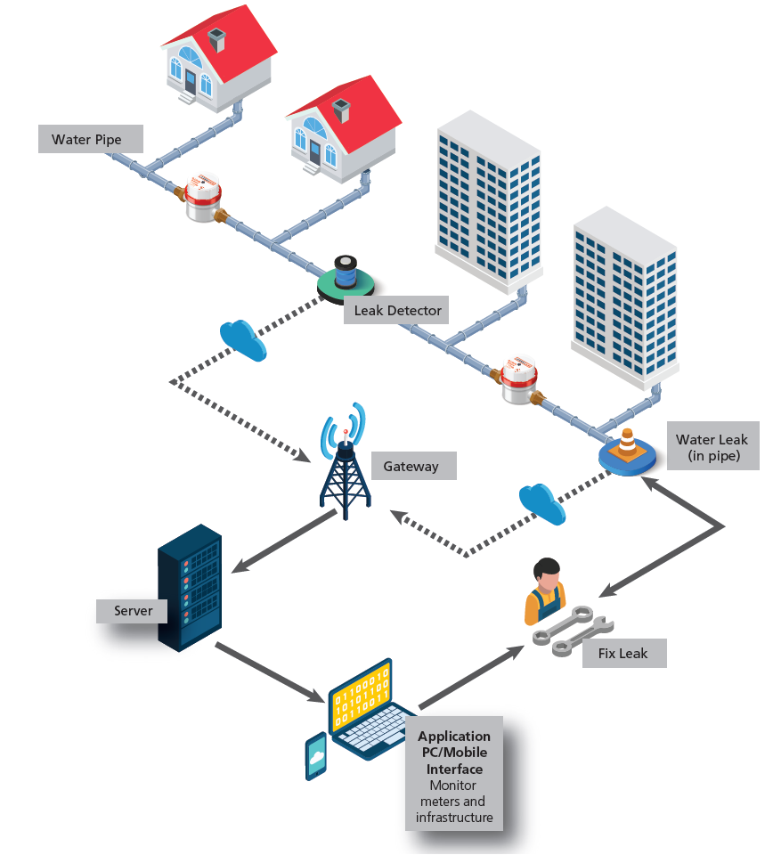

Figure 19 – Water flow monitoring

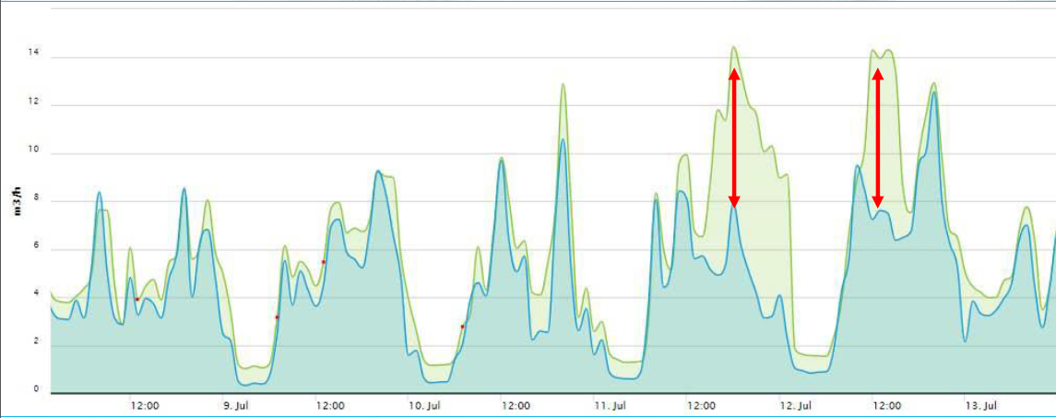

Figure 20 – Water network efficiency and anomaly detection

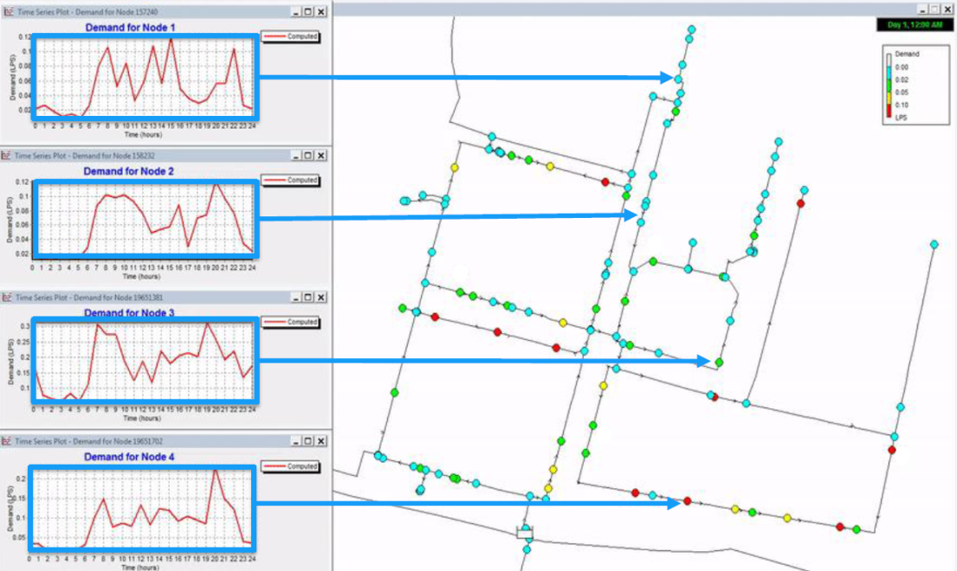

Figure 21 – Hydraulic model calibration

Following water metering, below figures are presenting some of the main vertical applications for which LPWAN-CSS technology is being used.

Within the smart building vertical the main applications are energy savings and occupancy optimization through measurement of values like temperature, humidity, CO2, presence, door or window opening, light intensity or noise level.

Hospitals are particular buildings where several categories of people and critical processes are on-going. Therefore healthcare is also an important area of application for LPWAN-CSS technology. In addition to the values mentioned above, inventory, gas cylinder level and tracking are very relevant to this application.

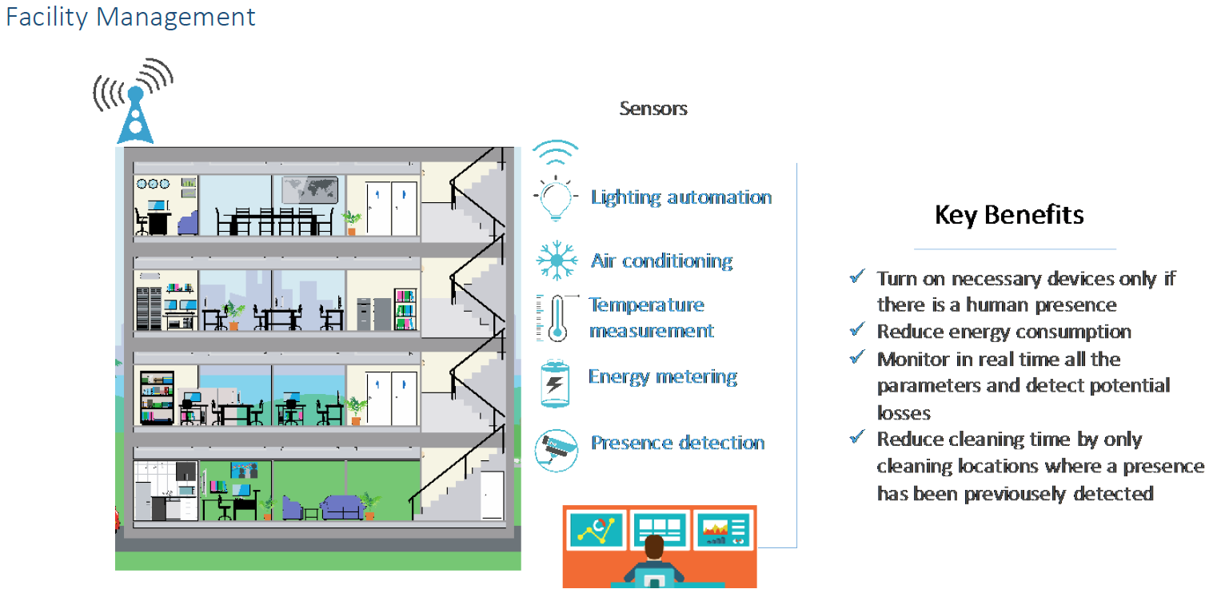

Figure 22 – Smart building vertical

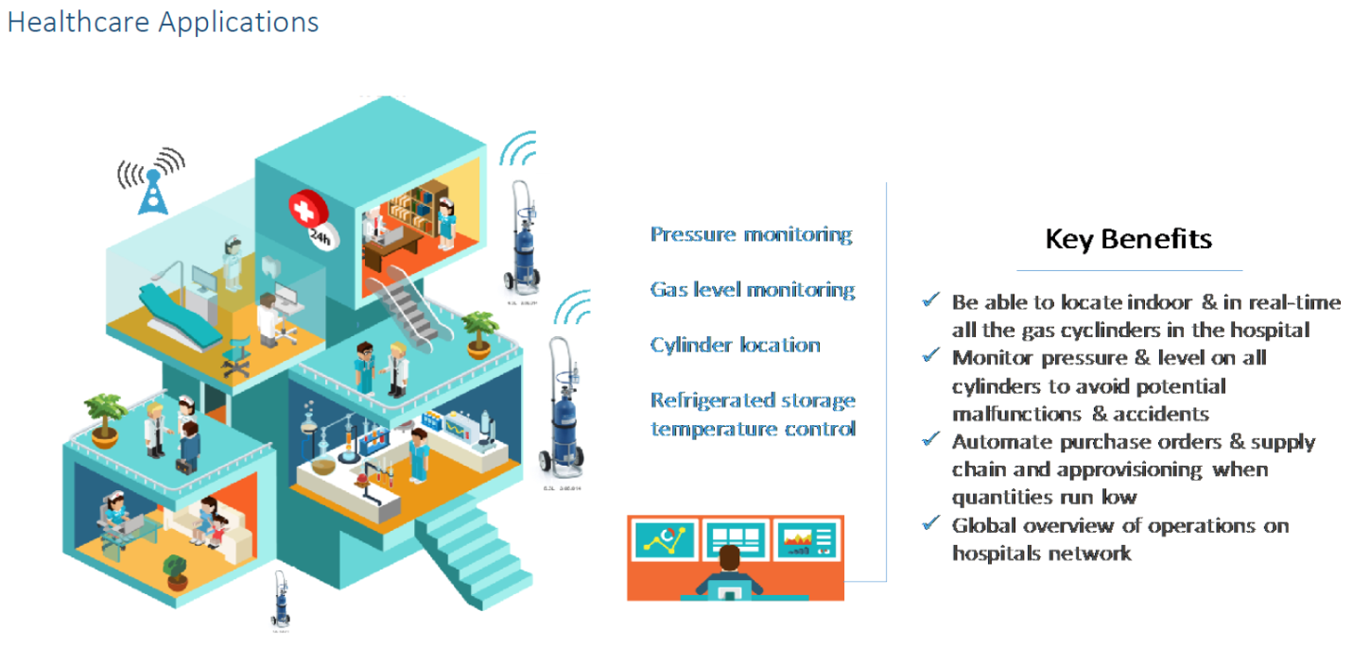

Figure 23 – Healthcare vertical

The other area where LPWAN-CSS technology has a great potential is Smart Industry. Maybe more than for other verticals the flexibility between private and public networks is particularly important here. For a usage that would be limited to a large facility, a private network would certainly be an attractive option while for smaller scattered sites the wide coverage of public networks would be more cost effective. Of course a large industrial company having both kinds of configurations is able to using the roaming capability to benefit from both coverage options at the same time. Among the numerous use cases of this vertical asset tracking is probably the more straightforward.

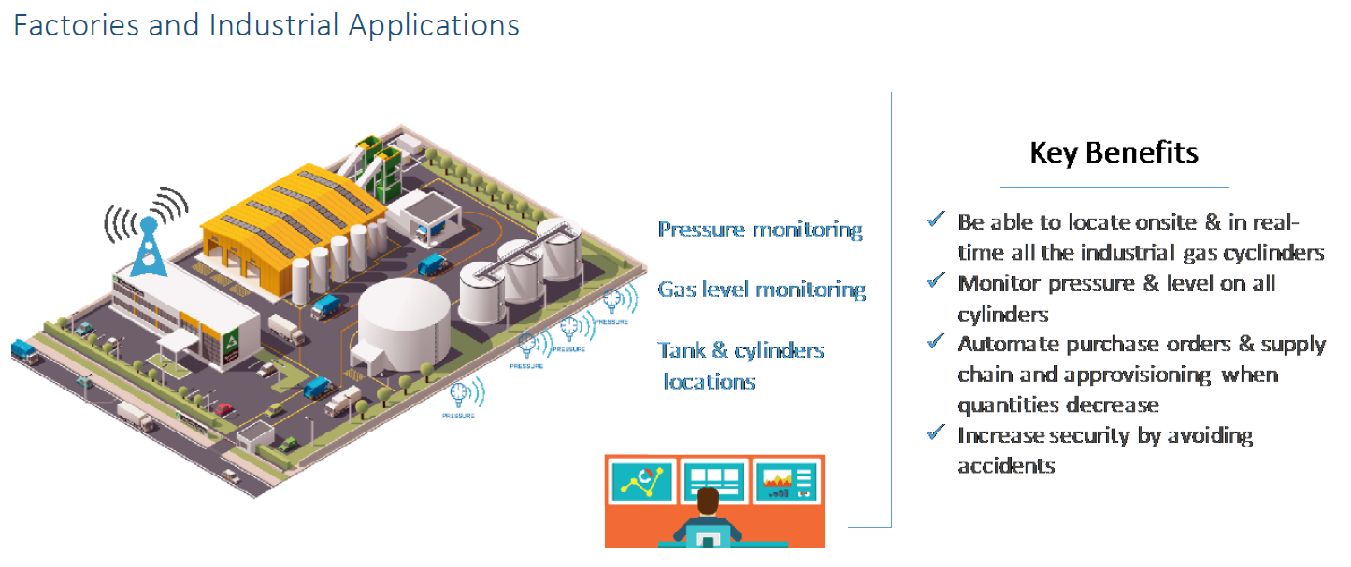

Figure 24 – Industry vertical

Airports are wider than a building and smaller than a city. In terms of use cases they are mixing both categories with some flavour of industrial applications as far as supply chain is concerned. Most of the smart building features apply to airports, from energy savings to passengers flow management. The main smart cities use cases like parking optimization, waste management and lighting control are also relevant to airports. Finally containers or even luggage tracking also helps minimizing the airplane time in the airport which is the overall target.

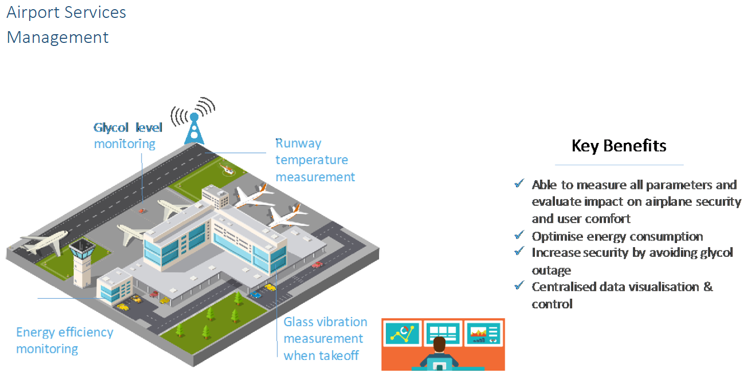

Figure 25 – Airport vertical

The following illustrations describe the main smart city applications which are smart parking and street lighting.

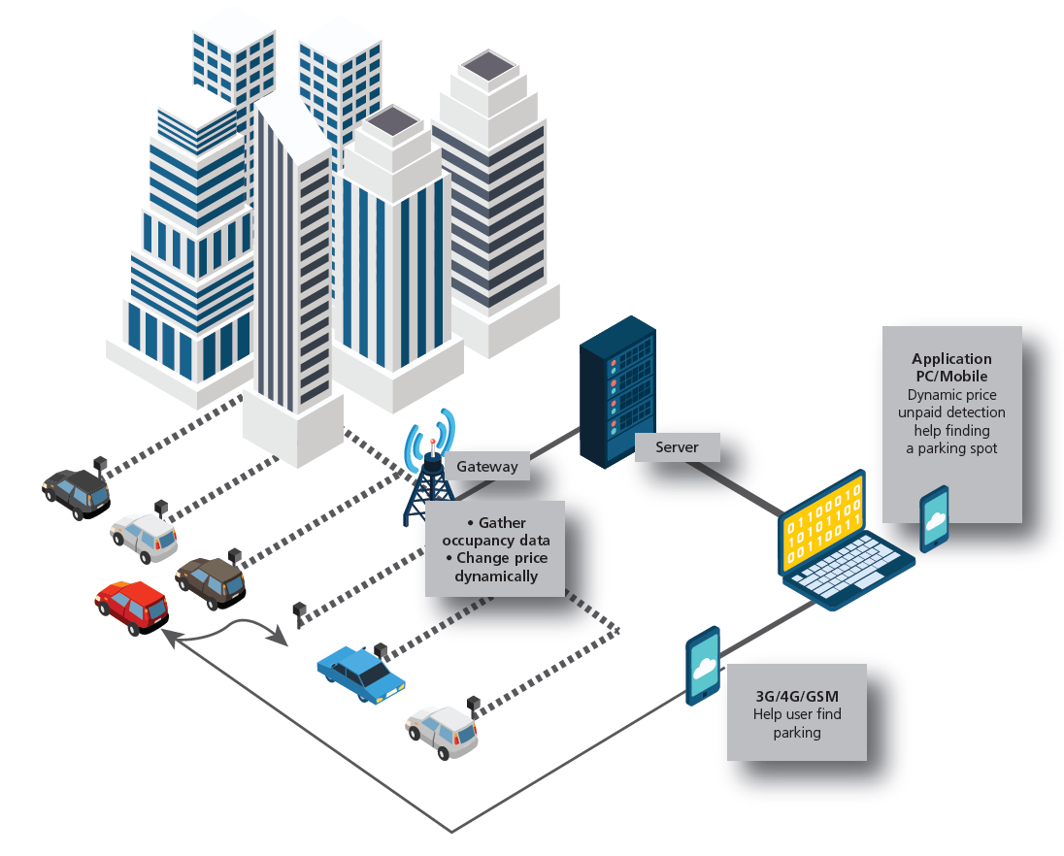

Figure 26 – Smart Parking use case

In this case, the communicating devices are located outdoor and their height can vary from the ground level to several meters high when they are mounted on street lamp posts.

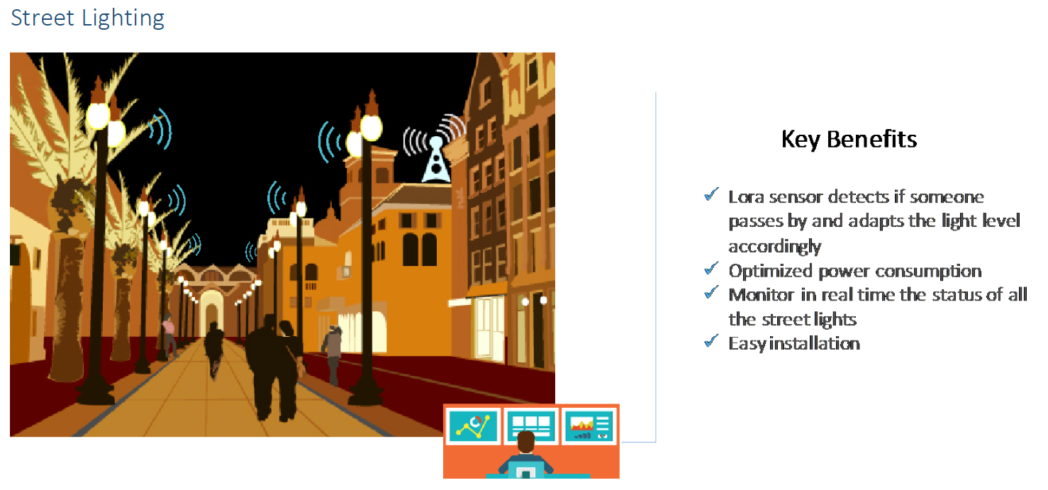

Figure 27 – Street lighting use case

Leaving the city space, wide area long range coverage is also the opportunity to address agriculture use cases. The two main applications are:

* Water and fertilizer optimisation through soil sensors
* Cattle tracking and health monitoring with ear tags or implants, including calving risks reduction

Of course, replication from smart building use cases to breeding buildings and industrial supply chain to food production process are also very relevant.

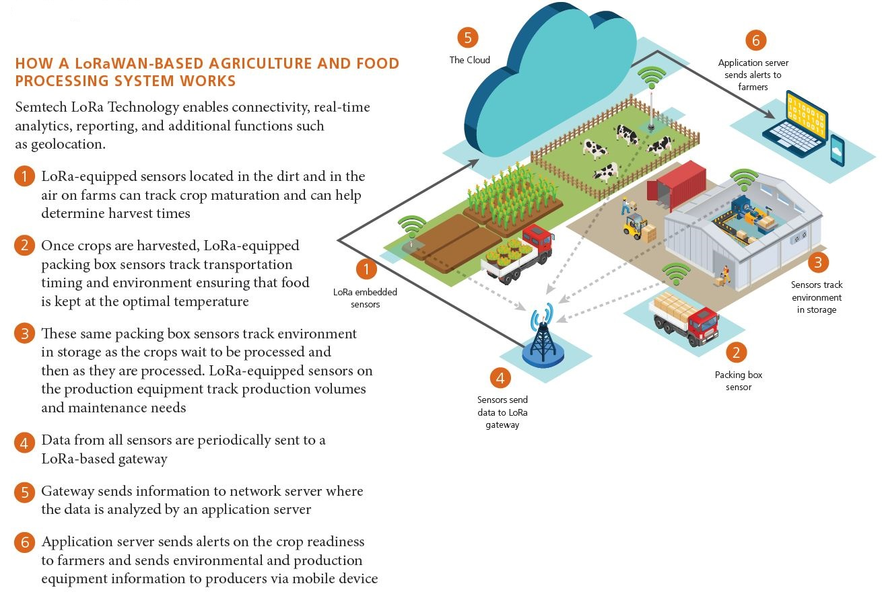

Figure 28 – Agriculture vertical

Annex C:  
Interference Experimental setup



Figure 29 : interference experimental setup

The victim receiver used consists of a Semtech SX1272 evaluation board configured as an FSK receiver. This FSK demodulation performance of this chip is within the industry average. It does not include any specific interference rejection circuitry or algorithm.

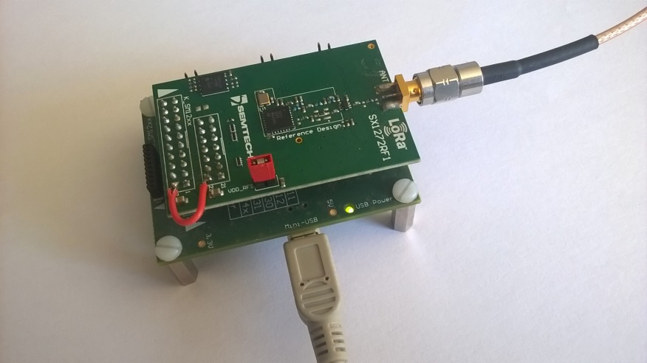

Figure 30 : FSK receiver

That receiver is connected via USB to a laptop to collect packet reception statistics. The interferer and the wanted signal are generated using calibrated professional signal generators (SMBV100A from R&S). Those instruments are also controlled by the laptop. The interferer and wanted signal power are calibrated at the input connector of the evaluation board.

For all measurements in this chapter the victim receiver is configured as follow:

|  |  |
| --- | --- |
| Param | Value |
| Demodulator | FSK |
| Bit rate | 100kBit/sec |
| Demodulator bandwidth | 200kHz |
| Center frequency (Fcenter) | 860MHz |
| Sync word | 24bits C194C1 |
| Receiver sensitivity (@0.1%BER) | -105dBm |

Table 14

The wanted signal generator is configured as follow:

|  |  |
| --- | --- |
| Param | Value |
| Modulation | GFSK , BT=0.5 |
| Bit rate | 100kBit/sec |
| Frequency deviation | 50kHz |
| Center frequency | 860MHz |
| Sync word | 24bits C194C1 |
| Payload size | 16 bytes (random values) |
| Signal power | -102dBm (sensi + 3dB) |

Table 15

The frequency of the interfering signal is swept in the range Fcenter +/- 300kHz with 10kHz step. For each frequency point the level of the interfering signal is varied until the Packet Error Rate of the victim receiver is 10%.

All measurement are done with a +/- 1.5dB precision.

##### Receiver’s AWGN sensitivity

We first characterize the receiver’s sensitivity without interference. The wanted signal power is swept, using 500 packets at each step.

../20170812/PER_grafico.pdf

Figure 31: Packet error rate as a function of the signal level

The receiver exhibits 10% Packet Error Rate at **-105dBm** corresponding roughly to 0.1% Bit Error Rate generally accepted as the definition of a receiver’s sensitivity level. We note that for a packet of 16 bytes 0.1% Bit Error Probability corresponds actually to a 13% Packet error probability:

For all subsequent measurements, the wanted signal power is set to **sensitivity + 3dB = -102dBm**

##### Continuous wave interference

The interferer is an un-modulated continuous signal with 100% duty cycle.

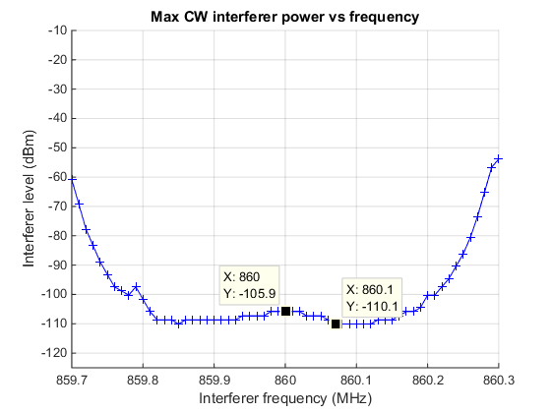

Figure 32 : CW interferer

In the bandwidth of the receiver (from 859.9 to 860.1 MHz), the interferer level tolerated varies between -110 to -106 dBm, for a wanted signal power of -102 dBm. This indicates that the FSK demodulator operates with Signal To Interferer ratio of 4 to 8 dB. At 50% PER and given the modulation parameters (specifically the high modulation index) the theoretical performance of the chip FSK demodulator is close 6dB SIR. Therefore this measurement confirms the expected theoretical result.

The slight asymmetry of the curve is due to a few kHz frequency offset of the receiver caused by an offset of its crystal timing reference.

##### GFSK modulated interferer

Two measurements were performed considering a GFSK modulated interferer.

1. 5kbit/sec / 25kHz frequency deviation modulated interferer
2. 100kbit/sec /50 kHz frequency deviation modulated interferer

In both case the Gaussian filter has a BT of 0.5. The interferer duty cycle is 100%

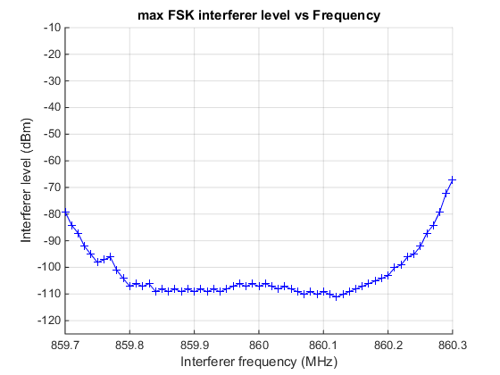

Figure 33 : GFSK modulated interferer, bit rate 5kbit/sec, Fdev=25kHz

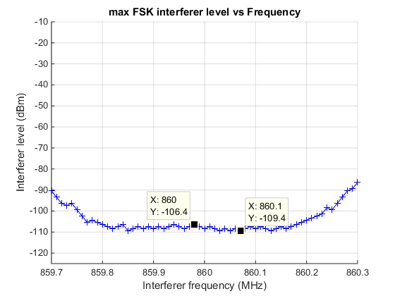

Figure 34 : interferer GFSK 100kbit/sec , Fdev=50kHz

Conclusion: The tolerable interferer level in the victim’s receiver bandwidth is nearly identical to the CW case for both modulated FSK interferers (-106 to -109 dBm).

Outside the bandwidth of the victim’s receiver (more specifically at +/- 300kHz offset) the receiver tolerance is reduced when the interferer is modulated as summarized in this table:

|  |  |
| --- | --- |
| Interference level @ +/-300kHz (average of -300kHz and +300kHz measured interferer level) | modulation |
| -58dBm | CW |
| -74dBm | GFSK 5kbit/sec : Fdev 25kHz |
| -89dBm | GFSK 100kbit/sec : Fdev 50kHz |

Table 13

This looks very logical. As the modulation bandwidth of the interferer increases the amount of energy spilled inside the victim’s receiver bandwidth increases. Therefore we would expect the CW interferer to have the minimum impact on the victim’s receiver outside the receiver bandwidth, which is experimentally verified.

##### LPWAN-CSS modulated Interferer

In this experiment the interferer is a LPWAN-CSS modulated signal with 125kHz bandwidth. Both the minimum (SF12) and maximum (SF7) data rate are measured. The interferer duty cycle is 100%.

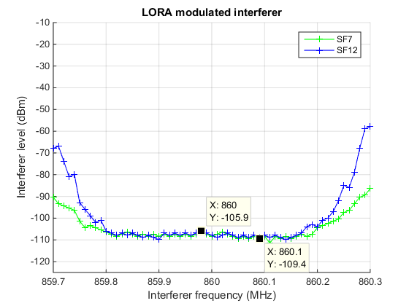

Figure 35 LPWAN-CSS interferer

Conclusion: once more, inside the receiver’s bandwidth the maximum tolerable interference level is identical to FSK or CW modulated interferers (-106 to -109.5dBm). It is worth noting that the interference tolerance does not vary with the LPWAN-CSS chirp rate used.

Outside the victim’s receiver bandwidth we can notice a difference between the two LPWAN-CSS modulated interferers. The lowest data rate interferer (SF12) corresponding to the slowest chirping modulation is better tolerated by the victim receiver’s at +/-300kHz offset. This is because the amount of energy spilled by the LPWAN-CSS modulator outside the 6dB modulation bandwidth (the 125kHz modulation bandwidth) increases with the data rate. The SF7 modulated interferer as a higher energy content at 200kHz offset and therefore “leaks” inside the victim’s receiver bandwidth. The SF12 modulated interferer nearly looks like a CW tone for the victim’s receiver at 300kHz offset. Whereas the impact of the SF7 modulated one is more comparable to the 100kbit/s GFSK modulated interferer previously measured.

The reason why the LPWAN-CSS modulation with spreading factor 7 (SF7) has a higher energy content outside the 200 kHz offset is that the change in the frequency occurs at a higher speed with respect to the case with spreading factor 12 (SF12): the sweep in the first case (SF7) occurs in 1 ms while in the second case (SF12) occurs in 32 ms and, furthermore, there are significant signal changes every 1 ms instead o 32 ms. That’s why the LPWAN-CSS modulation with spreading factor 12 (SF12) looks more like a continuous wave for the victim receiver.

# Annex D: An example of interference measurement with a single LPWAN CSS link and a single periodic pulsed CW interferer

Some co-channel interference measurements are reported in Figure 36, using as a victim a LPWAN-CSS signal with an occupied bandwidth of 125 kHz bandwidth and SF12. The LPWAN-CSS signal with SF12 is the most robust against interference among the possible LPWAN-CSS signals. The interference we consider is a pulsed tone, with a constant ( )of 10%. While on, the interference level is -20dBm, therefore the average interference level is -30 dBm. For a given measure, and , times are constant, with = 9⋅ . The period is varied from 0.01 ms to 1s. The results are shown below on Figure 36. On the figure, the sensitivity level without interferer is also reported, which is almost 20dB below the noise floor.

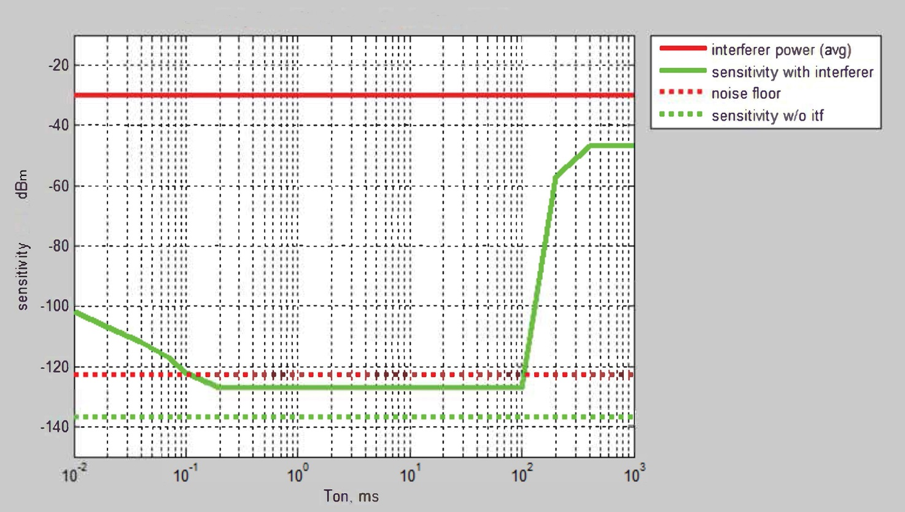

Figure 36: pulsed co-channel interferer rejection, SF12

The main thing to notice is that the receiver can tolerate up to -100dB SIR: the interference can be 100dB higher than the wanted signal, and still the packet error rate is kept below 10%. 100dB higher means that while the interference is present, absolutely no useful signal can be received. This happens when the Ton time of the interference is shorter than 100ms, and longer than 0.1 ms. For higher data rates, these numbers are expected to scale linearly with spreading factor. Here 100ms correspond roughly to 3 symbols (4096\*3/125e3 = 98ms). It has to be notice that for SF11 in the same configuration it is assumed that the interference Ton should be shorter than 50ms, 24ms for SF10, 12ms for SF9, 6ms for SF8 and 3ms for SF7.

When the interference lasts longer than this threshold, its impact is close to a continuous interference, so the SNR table applies.

# Annex E: Out of band emission measurements

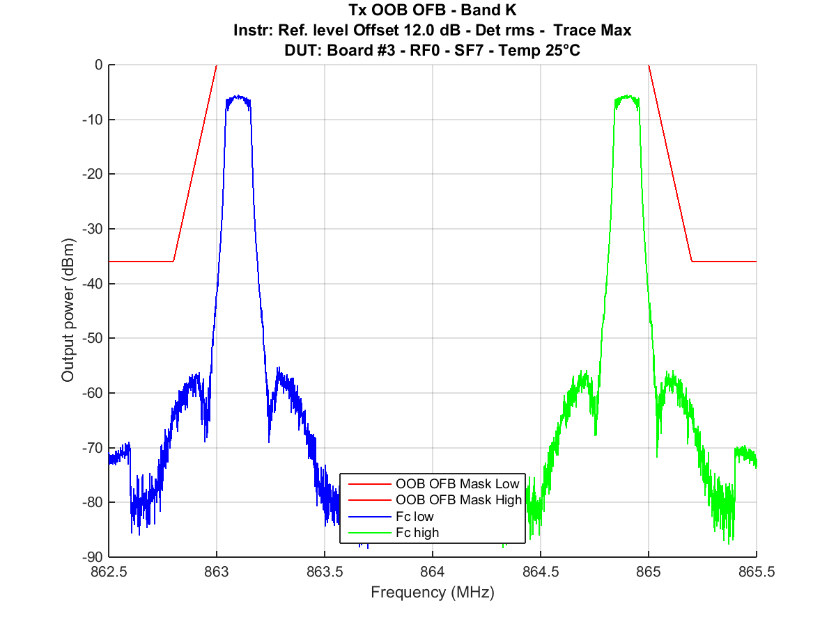

Figure 37: Tx Out Of Band Emissions - Band K

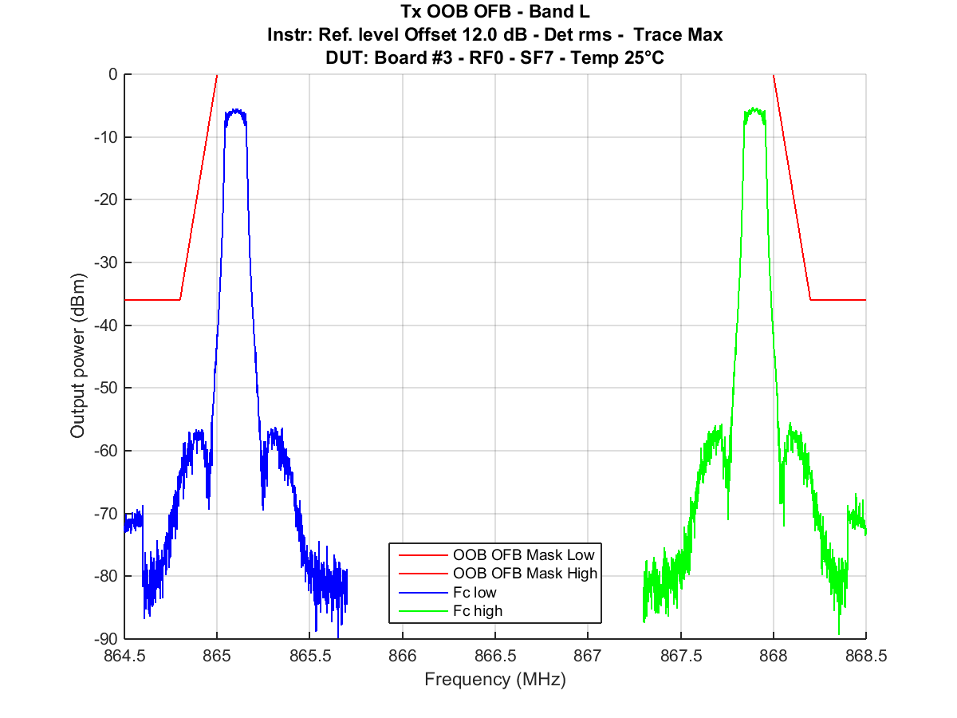

Figure 38: Tx Out Of Band Emissions - Band L

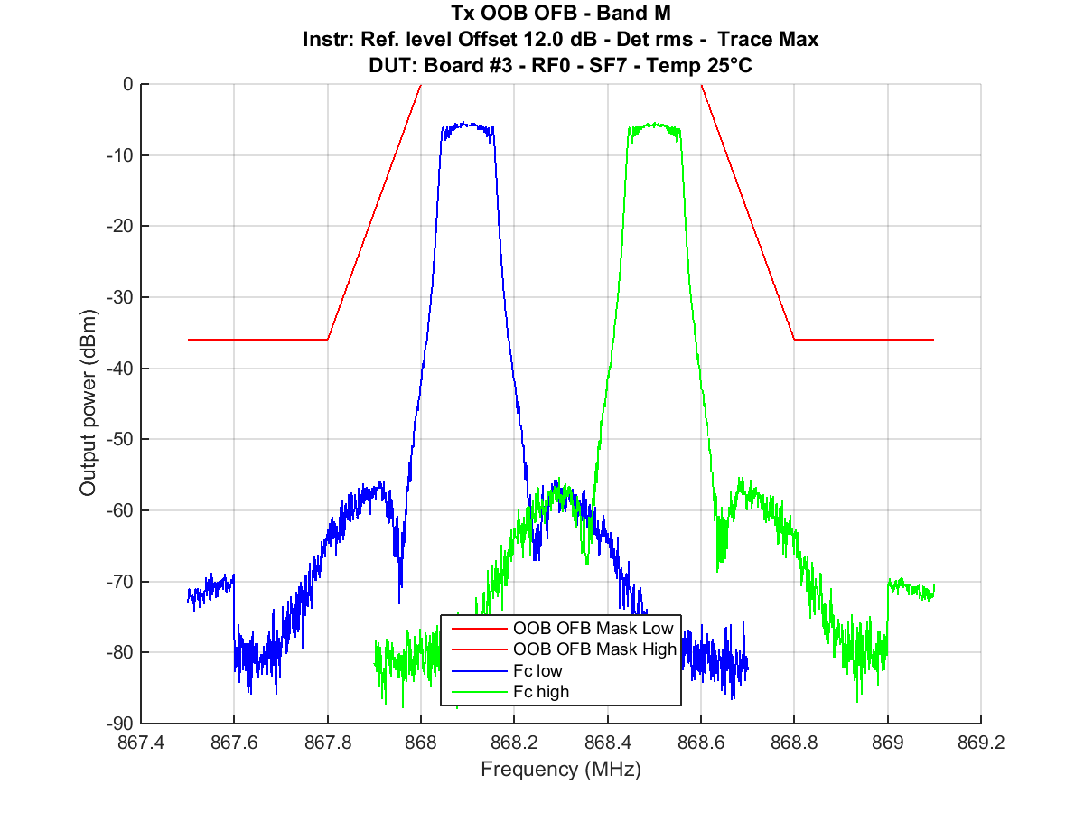

Figure 39: Tx Out Of Band Emissions - Band M

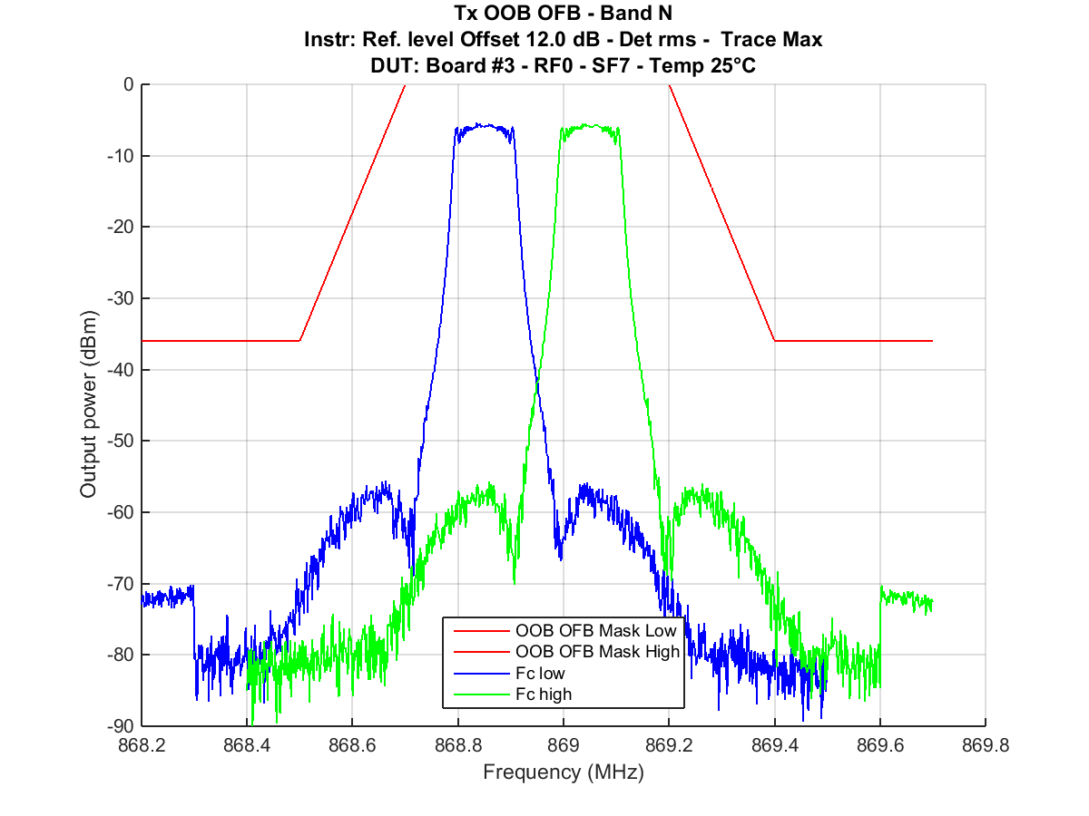

Figure 40: Tx Out Of Band Emissions - Band N

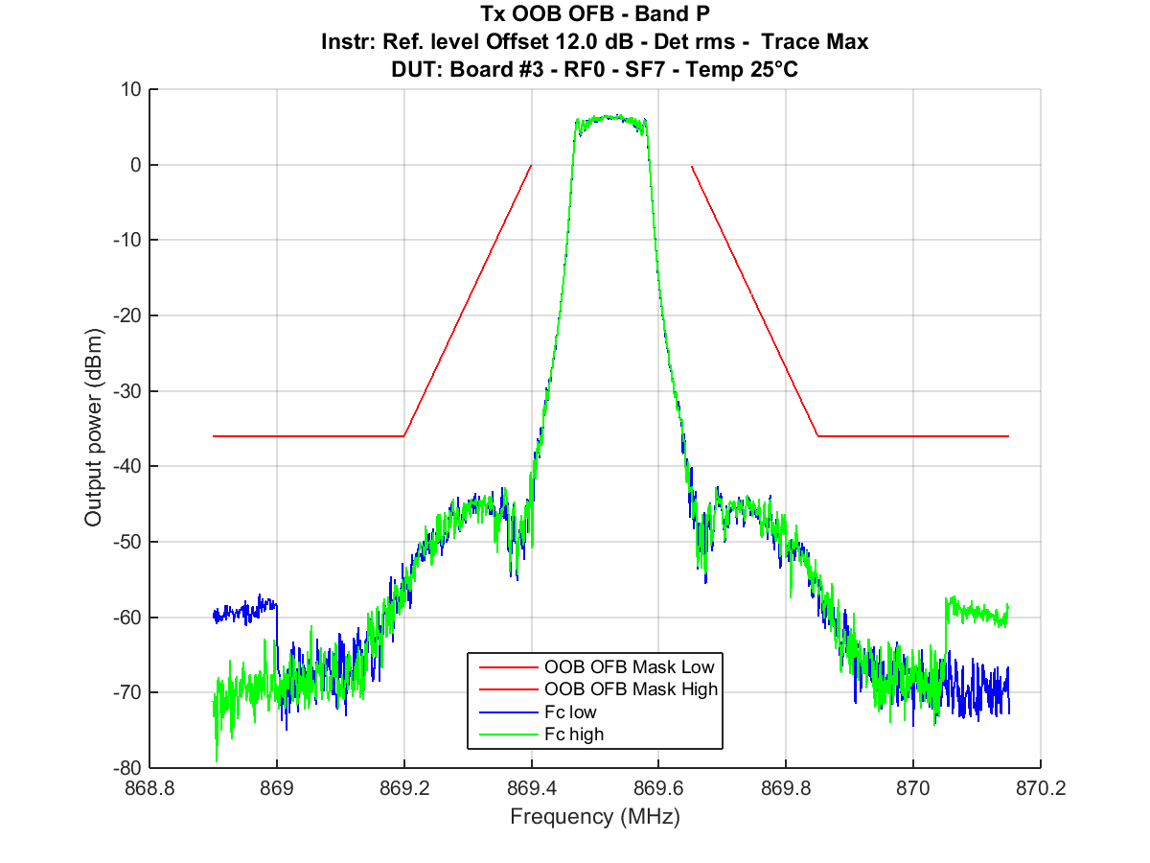

Figure 41: Tx Out Of Band Emissions - Band P

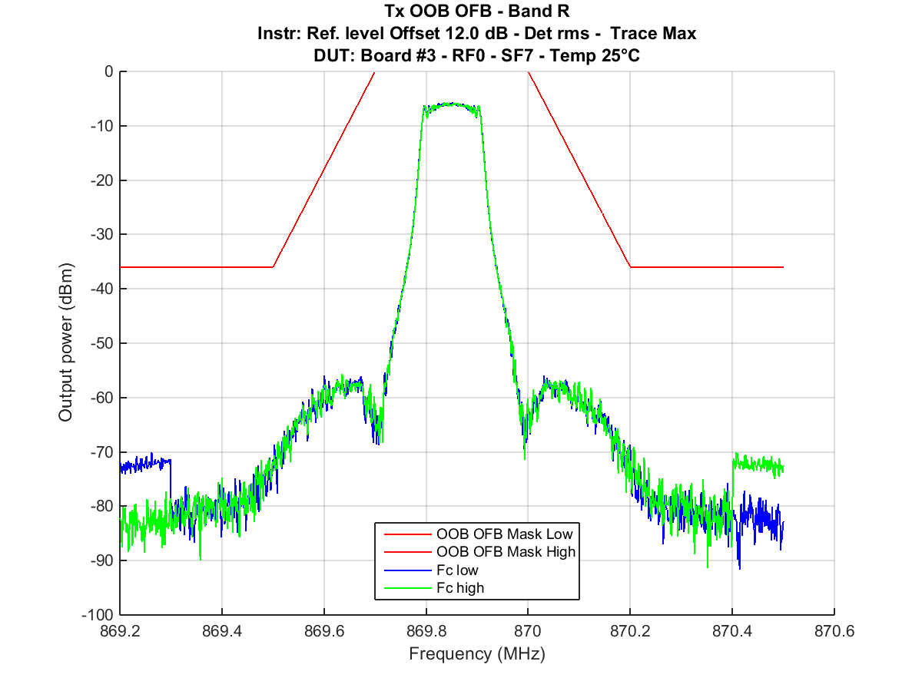

Figure 42: Tx Out Of Band Emissions - Band R

Annex :  
Change History

| Date | Version | Information about changes |
| --- | --- | --- |
| <Month year> | <#> | <Changes made are listed in this cell> |
|  |  |  |
|  |  |  |
|  |  |  |

# History

|  |  |  |
| --- | --- | --- |
| **Document history** | | |
| <Version> | <Date> | <Milestone> |
|  |  |  |
|  |  |  |
|  |  |  |
|  |  |  |

1. Actually, the paragraph describing figure 30 is ambiguous: it is not clear if the Ton range is 0.01ms-1s, or the Ton+Toff range (equal to 10 x Ton). [↑](#footnote-ref-1)